**CSEN 241: Cloud Computing HW 1**

**Title: System VS OS Virtualization**



**By:**

|  |  |  |
| --- | --- | --- |
| Name | Student ID | Email ID |
| Kartiki Rajendra Dindorkar | 1651519 | [kdindorkar@scu.edu](mailto:kdindorkar@scu.edu) |

Table of Contents

I. System Configurations 1

II. GitHub Repository 1

III. QEMU Installation and Ubuntu 20.04 1

IV. Ubuntu 20.04 Configuration on QEMU 1

V. Install SysBench on QEMU Ubuntu VM 1

VI. SysBench Manual 1

VII. Docker Installation 1

VIII. Ubuntu 20.04 with SysBench on Docker 1

IX. Experiments 1

A. QEMU (System Virtualization) 1

1. Image Format: raw 1

2. Image Format: qcow2 1

B. Docker (OS Virtualization) 1

X. Automation 1

A. QEMU 1

B. Docker 1

XI. Analysis 1

XII. Vagrant 1

XIII. Encrypted Image 1

XIV. References 1

# System Configurations

|  |  |
| --- | --- |
| Operating System | MAC OS Sonoma 14.2.1 |
| Chip | Apple M2 |
| System Architecture | arm64 |
| Memory | 8 GB |
| Number of Cores | 8 (4 performance and 4 efficiency) |

# GitHub Repository

[GitHub - CloudComputing](https://github.com/Kartiki19/CloudComputing)

# QEMU Installation and Ubuntu 20.04

Refer to [QEMU and Ubuntu 20.04 Setup](https://github.com/Kartiki19/CloudComputing/blob/main/HW1/QEMUUbuntuSetup.md) (QEMUUbuntuSetup.pdf attached in the HW1 folder) for Installing QEMU on Apple MAC M2 chip and setting Ubuntu 20.04 OS. Following are the steps for Ubuntu Setup:

1. Click on Install Ubuntu Server

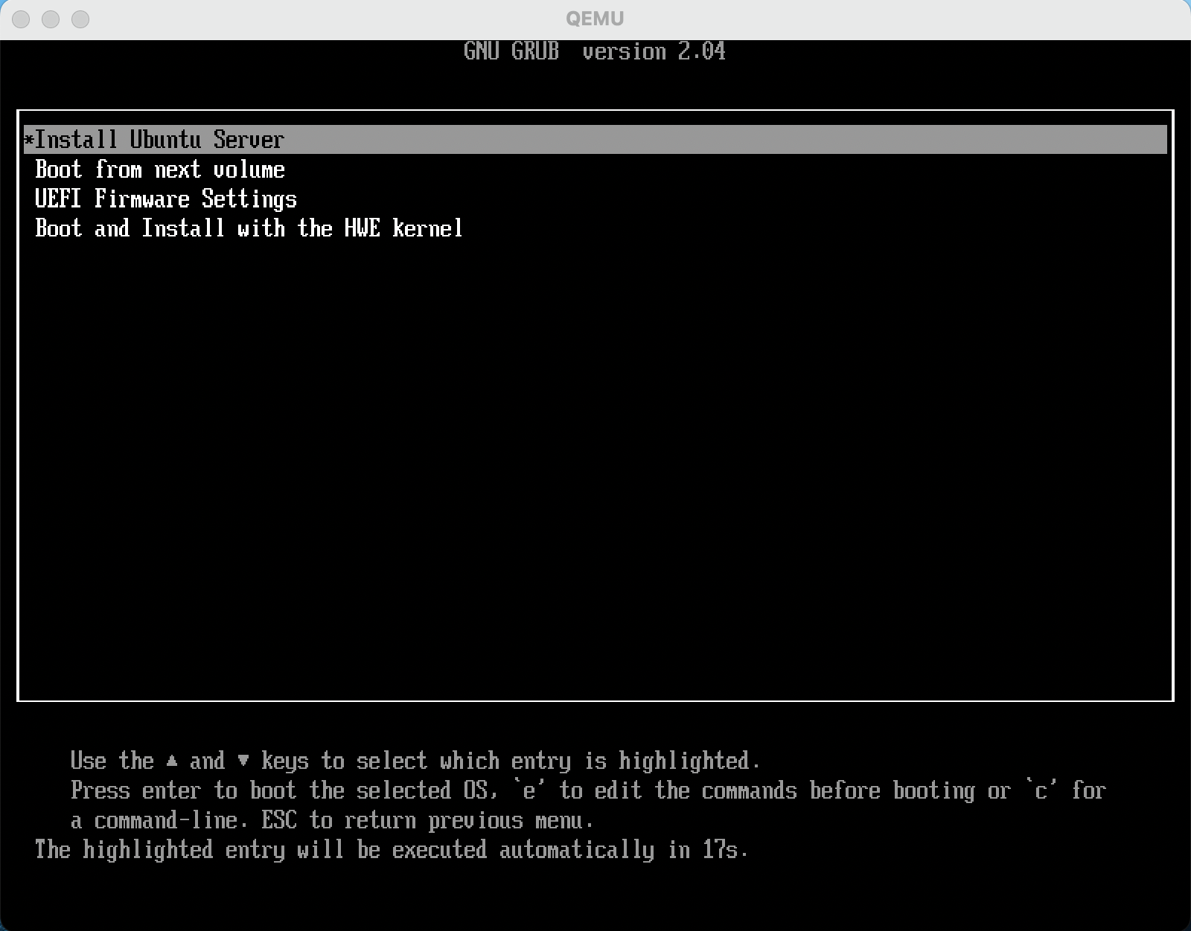

1. Select the language

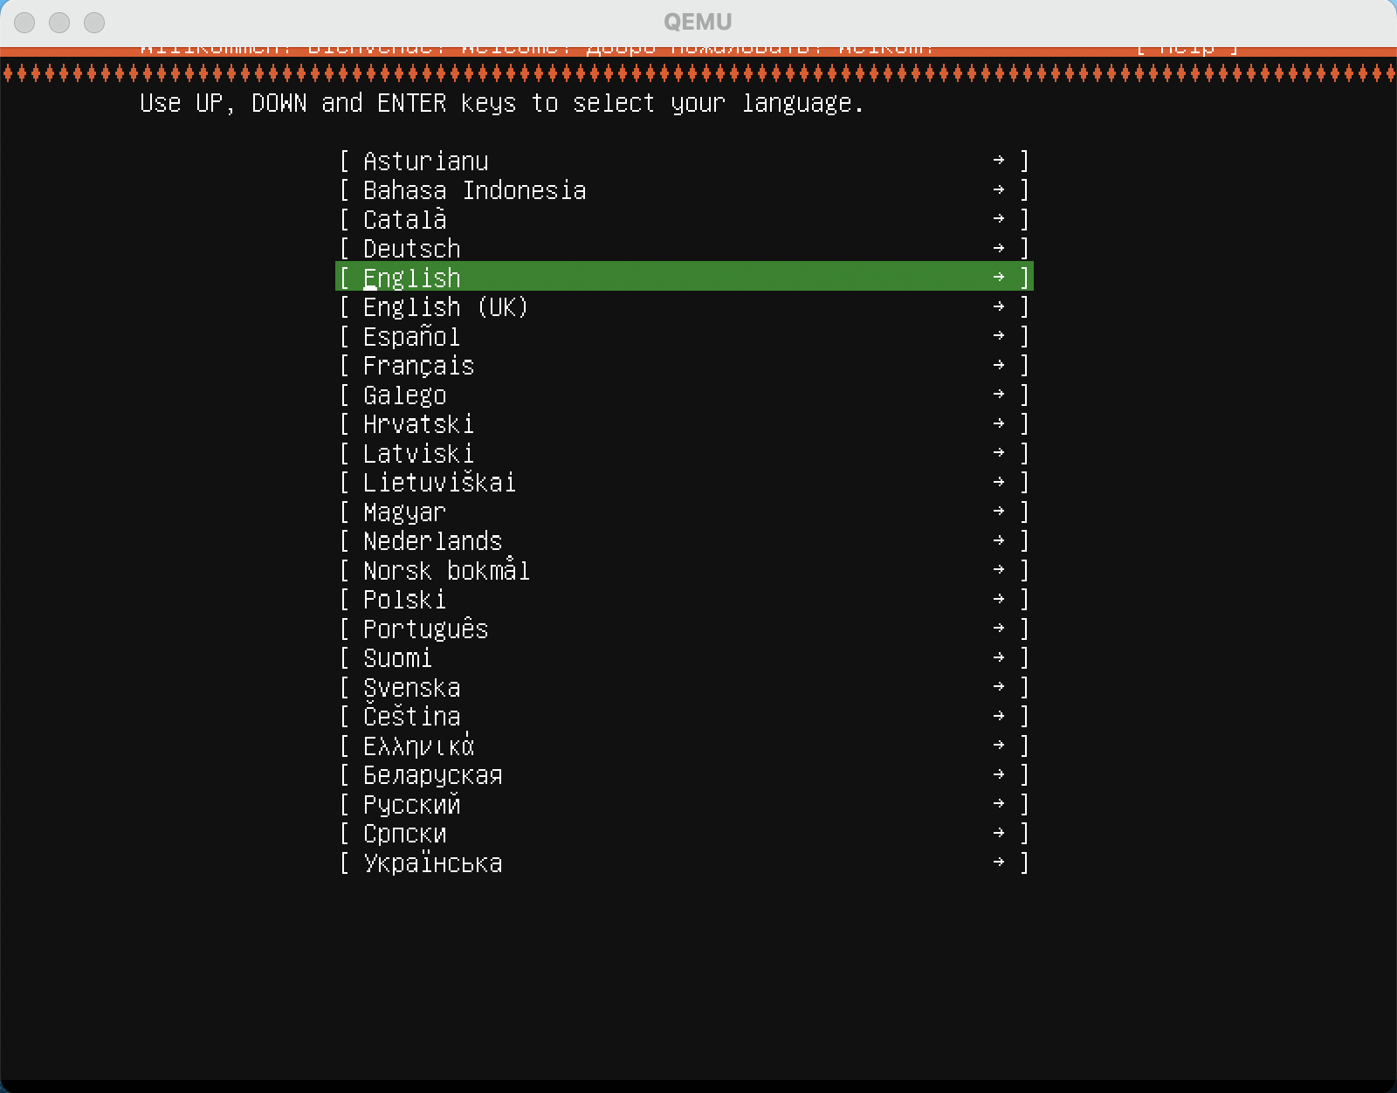

1. Select Keyboard Layout

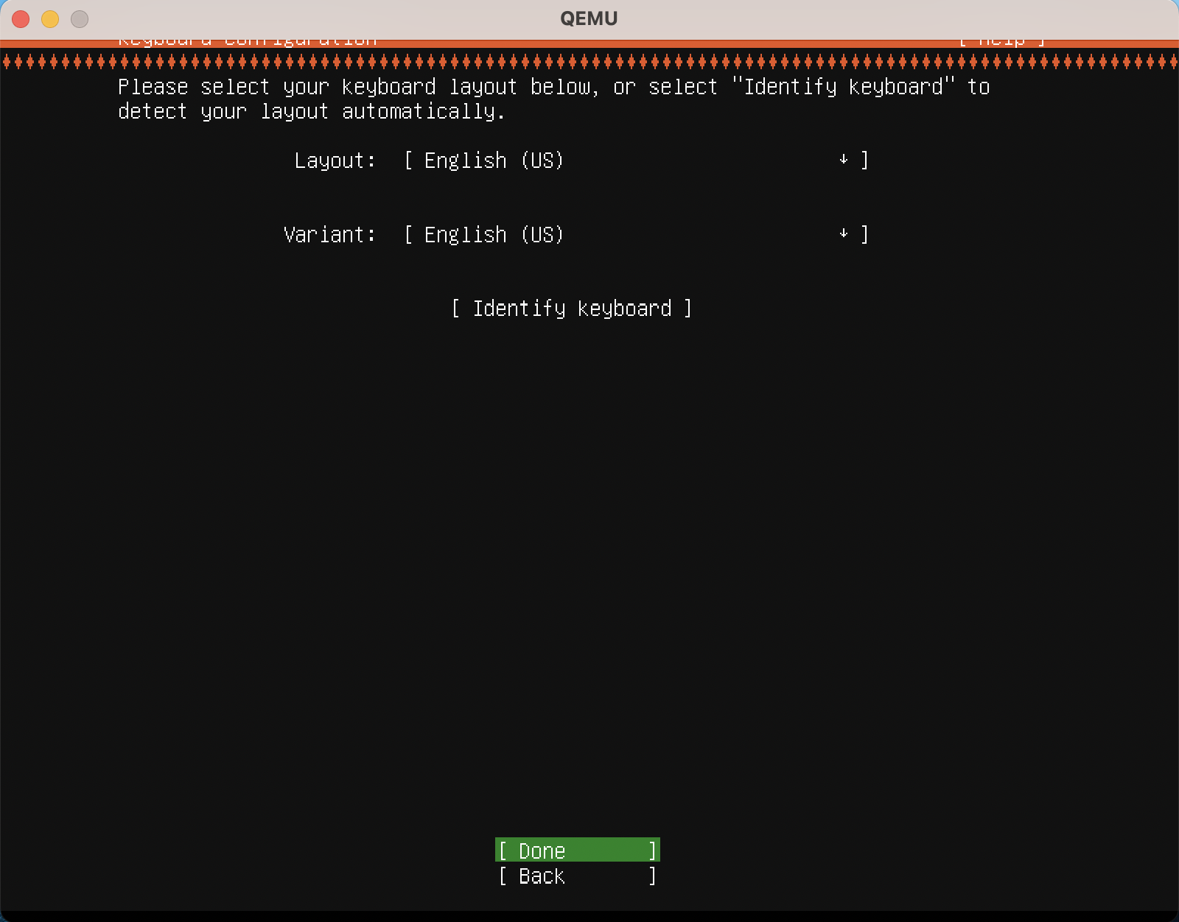

1. Select the Update option

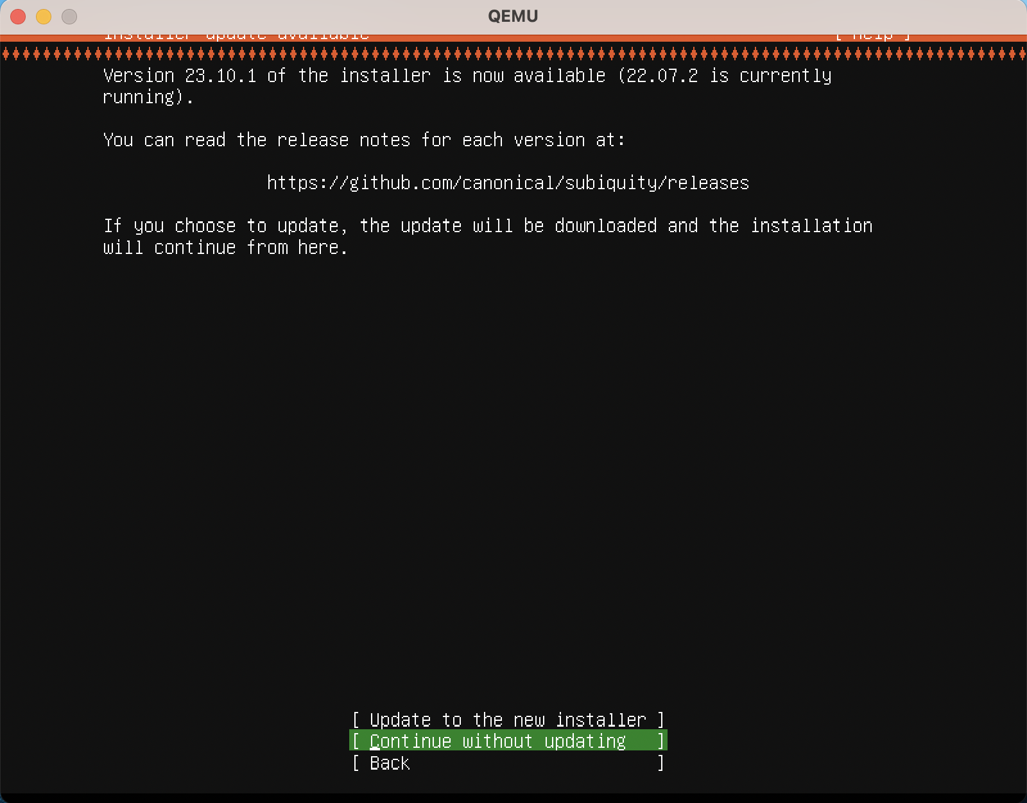

1. Internet Connection

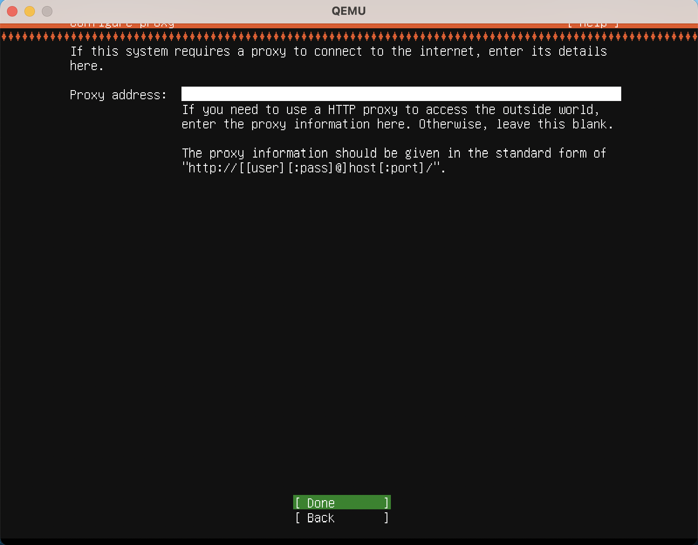

1. Mirror address

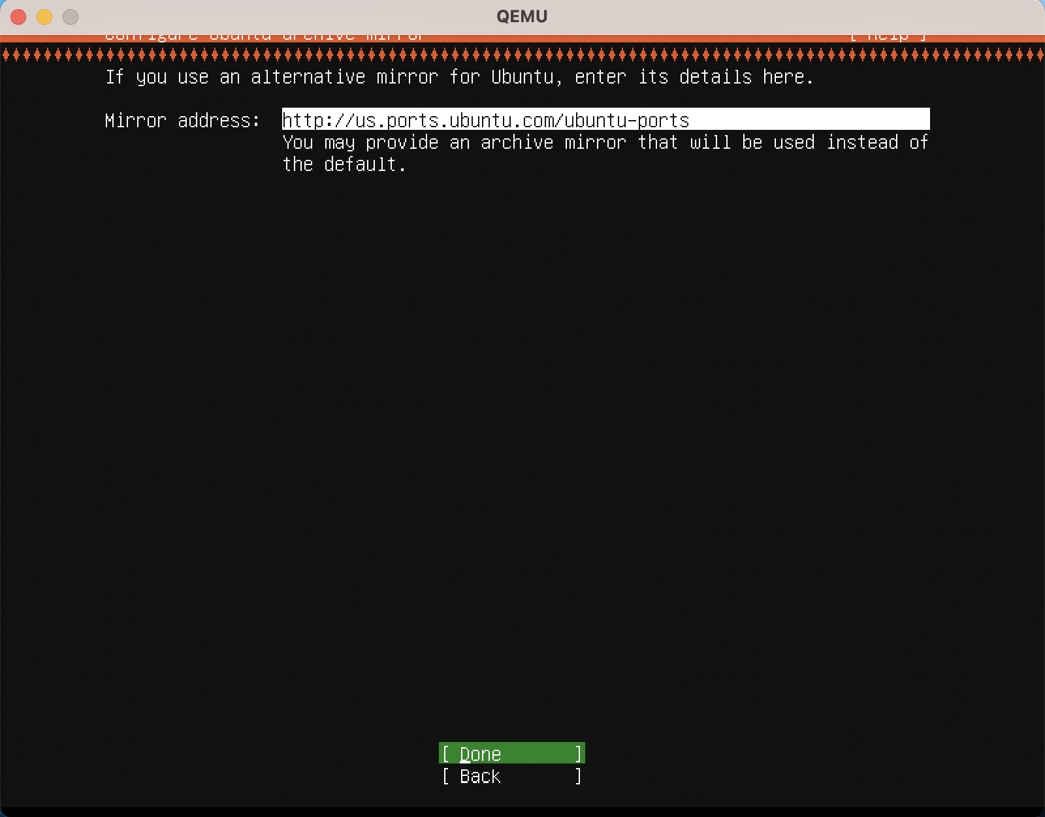

1. Configure Storage

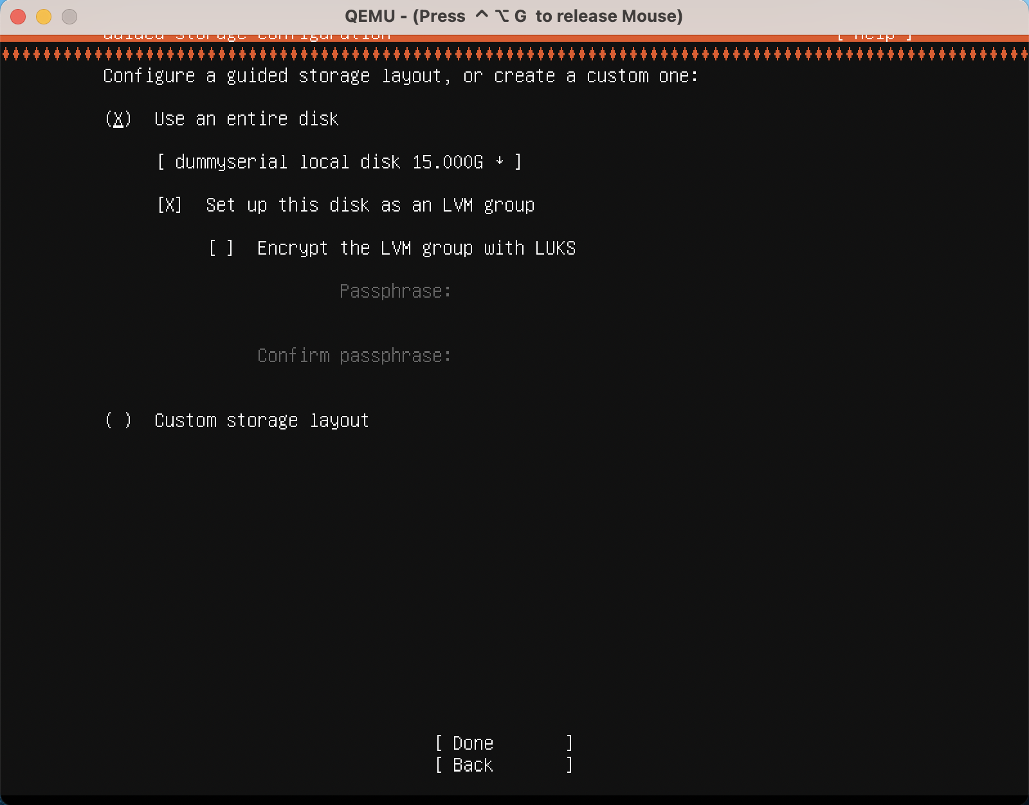

1. File System Summary

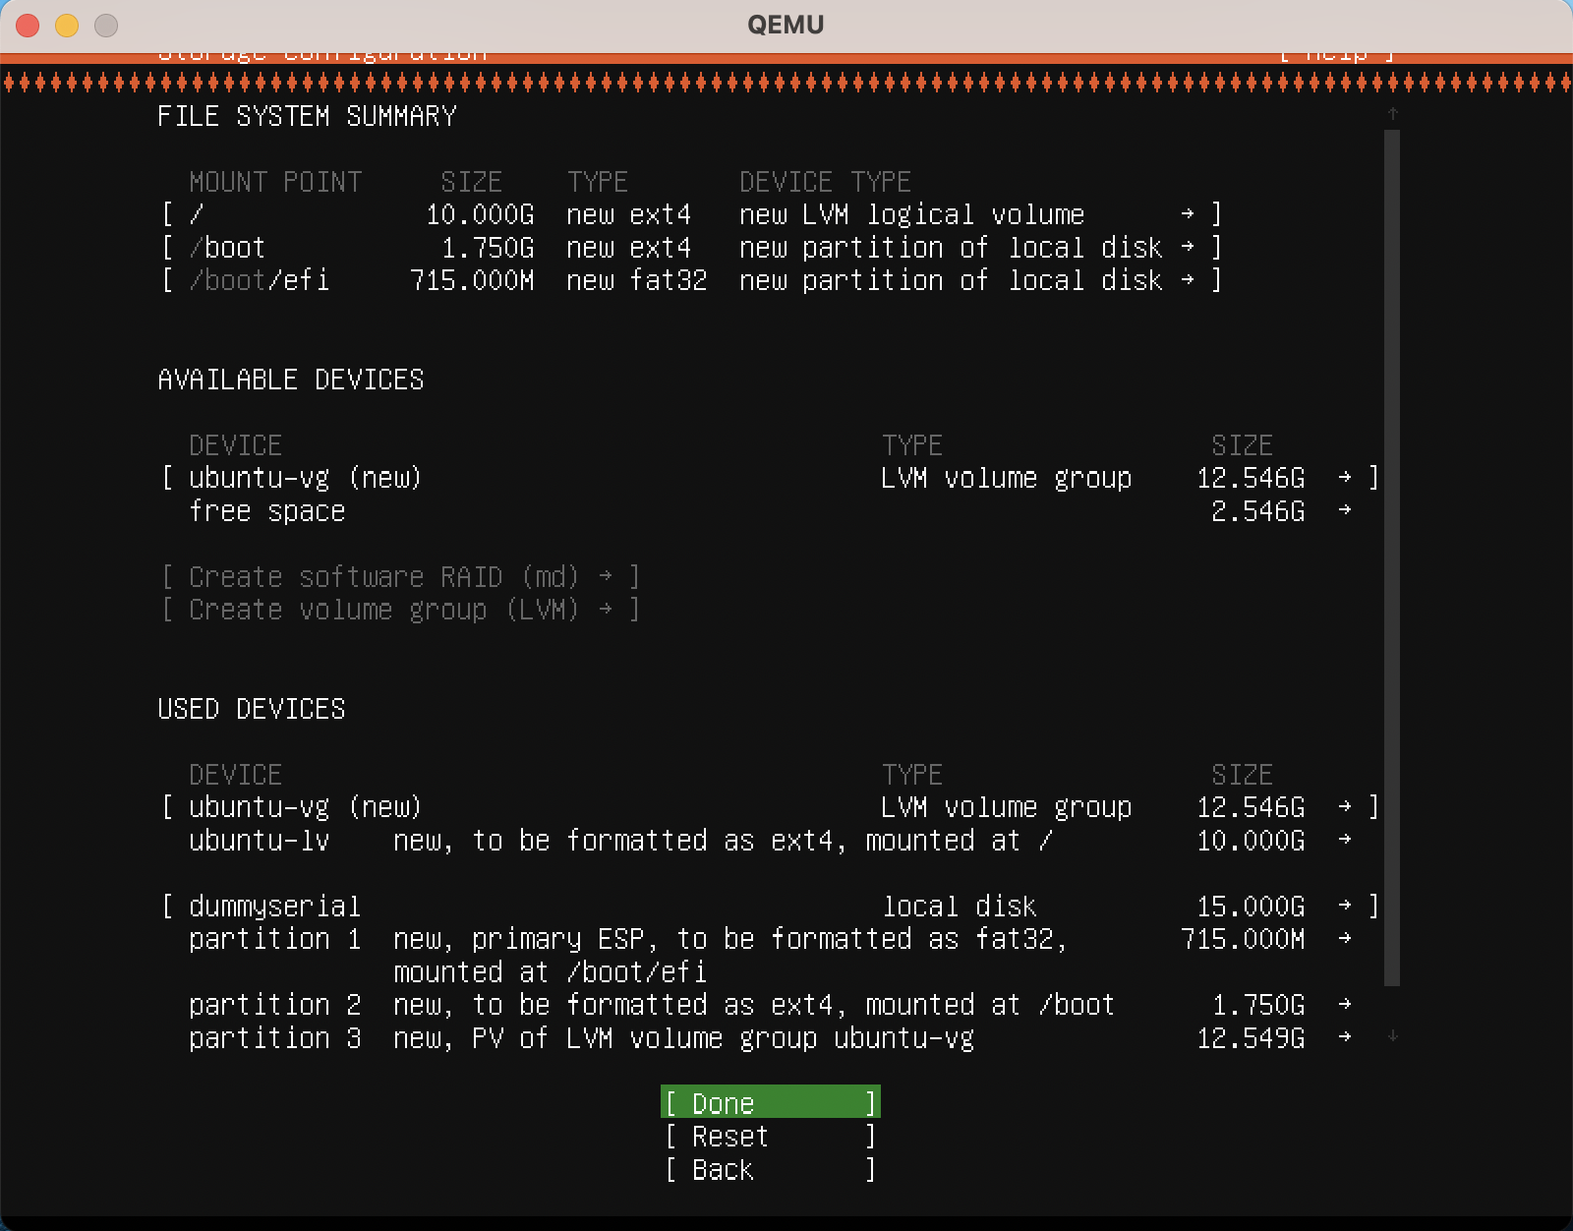

1. Username and Password Configuration

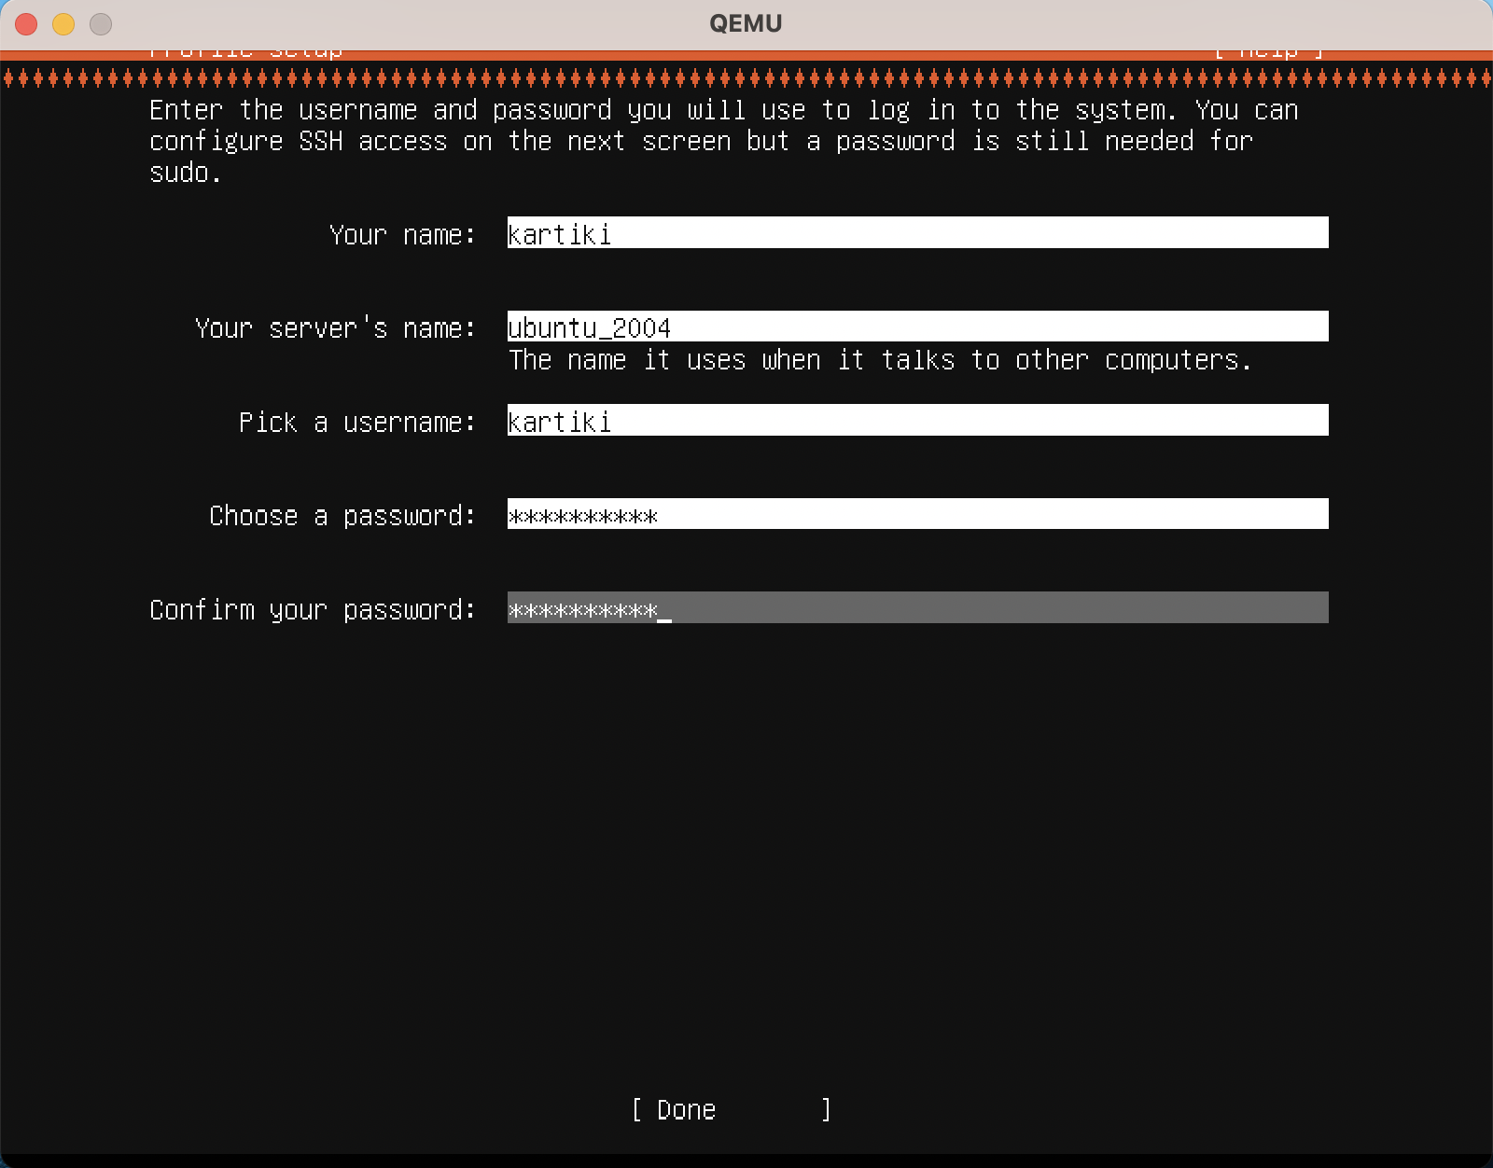

1. OpenSSH Package Installation

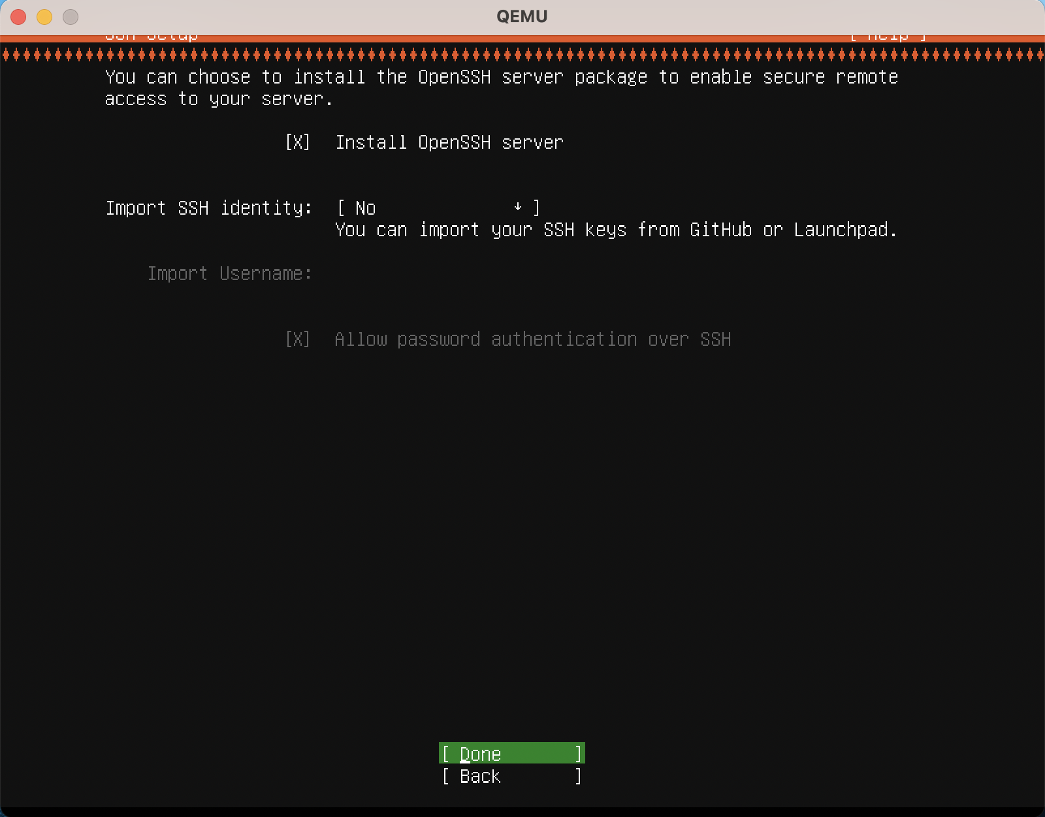

1. Package Installation

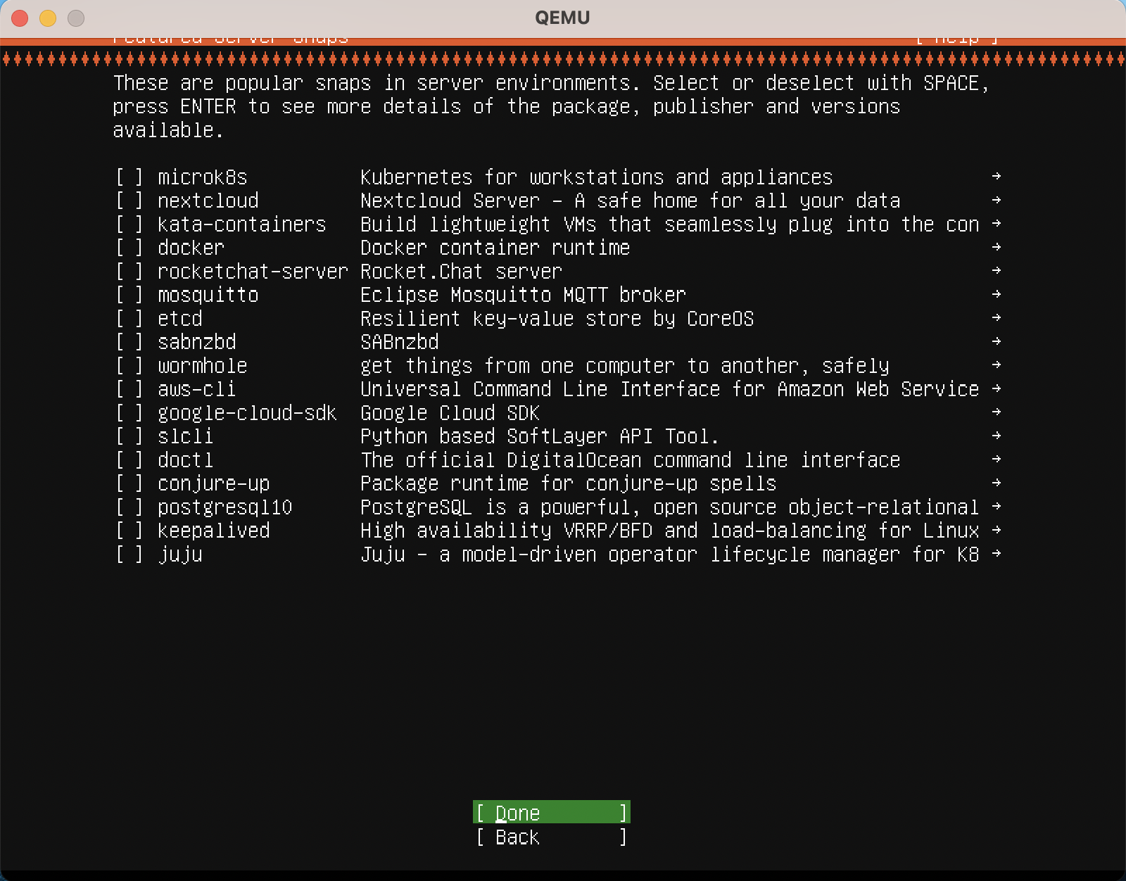

# Ubuntu 20.04 Configuration on QEMU

After [creating raw image](https://github.com/Kartiki19/CloudComputing/blob/main/HW1/QEMUUbuntuSetup.md#create-qemu-raw-format-image) to [install it using installation command,](https://github.com/Kartiki19/CloudComputing/blob/main/HW1/QEMUUbuntuSetup.md#demo) let us look what all the used flags means:

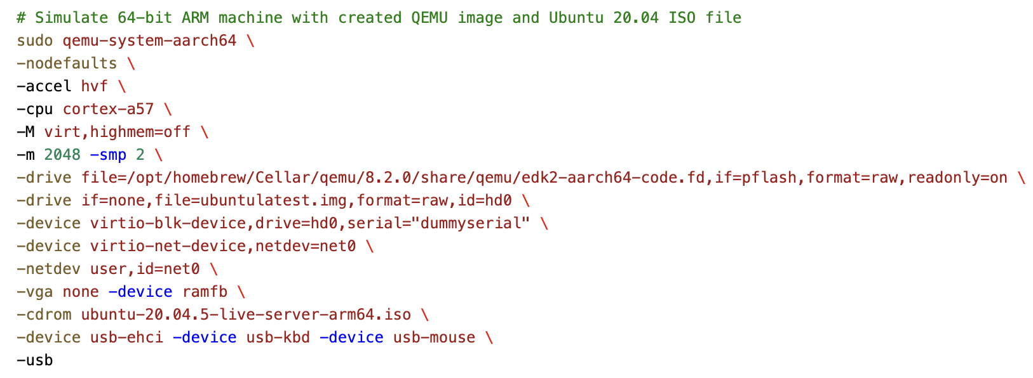

|  |  |
| --- | --- |
| qemu-system-aarch64 | QEMU [package](https://github.com/Kartiki19/CloudComputing/blob/main/HW1/QEMUUbuntuSetup.md#check-available-qemu-packages) to simulate 64-bit ARM machine. |
| -nodefaults | Don’t create default devices like serial port, parallel port, VGA adapter, etc. |
| -accel | Enable an accelerator depending on target device. (kvm, xen, hvf, nvmm, whpx or tcg). |
| -m | Guest startup RAM size, default is 128 M, here we are allocating 2 Gb RAM. |
| -smp | Number of CPU allocating to the VM, here we are allocating 2 CPUs. |
| -drive file=file | Defines a new drive and which disk image to use with this drive. |
| -device | Adds device driver, here we have added, keyboard, mouse, ehci, network device and block device. |
| -netdev | Configures user mode host network backend. |
| -vga | Selects type of VGA card. |
| -cdrom file | Use the file as CD-ROM image to boot the ISO file. |
| -usb | Enables USB emulation on machines with on-board USB host controller. |

# Install SysBench on QEMU Ubuntu VM

1. Once you sign in with your username and password on Ubuntu VM, install “SysBench” using following commands:

$ sudo apt update

$ sudo apt install sysbench

1. Check the SysBench version using:

$ sysbench –version

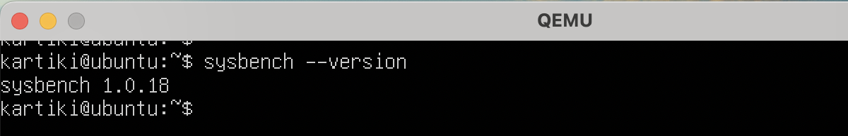

# SysBench Manual

1. The general format of SysBench is:

$ sysbench [common-options] --test=name [test-options] command

1. Use “cleanup” command to remove temporary data after the test run:

$ sysbench --test=fileio --file-total-size=3G cleanup

1. Multiple Common options are:

|  |  |  |
| --- | --- | --- |
| **Option** | **Description** | **Default Value** |
| --num-threads | Total no of threads to create | 1 |
| --max-requests | Total number of requests (0=Infinite) | 10000 |
| --max-time | Limit total execution time (sec) | 0 |
| ---forced-shutdown | Amount of time to wait after –max-time to force shutdown. (sec / %) | off |
| --test | Name of the test mode to run | REQUIRED |
| --debug | Display more debug info | off |
| --validate | Validate the test results | off |
| --batch | Periodic dump of current status of run | off |
| --batch-delay | Delay between batch dump (sec) | 300 |

1. Batch option can be utilized as:

$ sysbench –batch –batch-delay=5 –test=cpu –cpu-max-prime=500 run

1. Test Modes:
   1. **CPU:** Using *–cpu-max-primes* option, we will request to calculate prime numbers up to specified value. Each thread executed concurrently until calculation is completed or *–max-time* is completed

$ sysbench –test=cpu –cpu-max-prime=50000 run

* 1. **Memory:** It is used to benchmark sequential memory reads or writes. Using –memory-block-size we can provide the size of memory block to use, its default value is 1 KiB.

$ sysbench –test=memory –memory-block-size=1000K run

* 1. **Fileio:** This test mode can help to produce multiple types of file I/O workloads
     1. Prepare stage – SysBench creates specified number files with specified total size.
     2. run stage – each thread performs a specified operation.
     3. Supported I/O Operations:

|  |  |
| --- | --- |
| seqwr | Sequential Write |
| seqrewr | Sequential Rewrite |
| seqrd | Sequential Read |
| rndrd | Random Read |
| rndwr | Random Write |
| rndrw | Random Read + Random Write |

* + 1. Test specific options:

|  |  |  |
| --- | --- | --- |
| Option | Description | Default Value |
| --file-num | No. Of files to create | 128 |
| --file-block-size | Block size to use in all I/O operations | 16 K |
| --file-total-size | Total Size of files | 2 G |
| --file-test-mode | Type of workload (supported I/O operations) | Required |

$ sysbench --test=fileio --file-total-size=1G --file-test-mode=rndrw \ prepare

$ sysbench --test=fileio --file-total-size=1G --file-test-mode=rndrw \ run

$ sysbench --test=fileio --file-total-size=3G --file-test-mode=rndrw \ cleanup

# Docker Installation

Refer [Docker Installation with Apple Mac M2](https://github.com/Kartiki19/CloudComputing/blob/main/HW1/DockerInstallation.md) (DockerInstallation.pdf is attached in the folder) chip and setting Ubuntu 20.04 OS.

# Ubuntu 20.04 with SysBench on Docker

1. Create a docker file as instructed in [create a Dockerfile](https://github.com/Kartiki19/CloudComputing/blob/main/HW1/DockerInstallation.md#create-a-dockerfile)

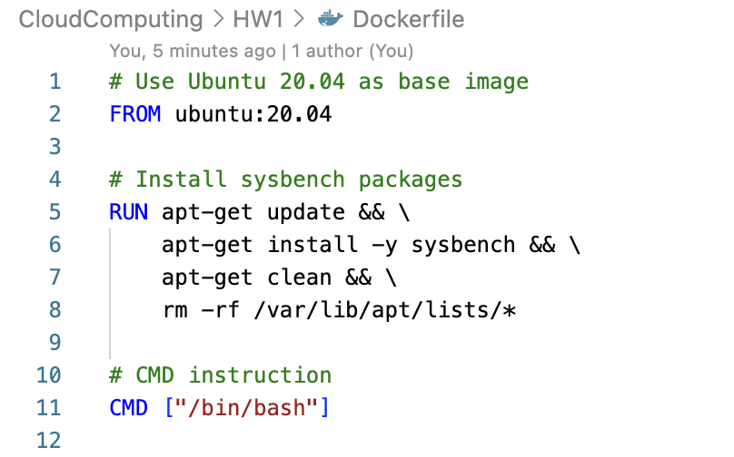

1. Build the image

$ docker build –t <image_name> .

1. Run the container

$ docker run --rm <image_name>

1. Run the container with different CPU and Memory allocation

$ docker run --cpus=<cpu_count> --memory=<memory_limit> \

<image_name>

1. Check the running containers

$ docker ps

1. List all the docker images

$ docker images

1. Getting the history of your image

$ docker history <image_id>

# Experiments

## A. QEMU (System Virtualization)

The experiment involves multiple test cases where there are variations in CPU and RAM allocated to the VM. Also, 3 test modes of SysBench will involve 2 variations each. Thus, the variables and their variations are listed below:

|  |  |  |  |  |
| --- | --- | --- | --- | --- |
| **Sr No.** | **Variable Category** | **Variable Name** | **Parameter Name** | **Values** |
| 1 | VM | Image Format |  | raw, qcow2 |
| 2 | VM | Number of CPU | -smp | 2, 4 |
| 3 | VM | Memory Allocated | -m | 2G, 3G |
| 4 | SysBench Test Mode | CPU | --cpu-max-prime | 30000, 60000 |
| Memory | --memory-block-size | 1G, 2G |
| FileIO | --file-test-mode | Sequential Write (seqwr), Random Write (rndwr), Random Read-Write (rndrw) |

### Image Format: raw

Instructions to create raw image format and running the VM is given in [QEMU and Ubuntu 20.04](https://github.com/Kartiki19/CloudComputing/blob/main/HW1/QEMUUbuntuSetup.md) Setup [QEMU and Ubuntu 20.04 Setup.](https://github.com/Kartiki19/CloudComputing/blob/main/HW1/QEMUUbuntuSetup.md)

Following are the SysBench test cases running on QEMU VM:

1. Raw image variations

As per the above table, for raw image format, created 4 variations to run SysBench Test Cases.

1. Raw Image with CPU = 2, Memory = 2G
2. Raw Image with CPU = 2, Memory = 3G
3. Raw Image with CPU = 4, Memory = 2G
4. Raw Image with CPU = 4, Memory = 3G
5. Running SysBench CPU test case:

$ sysbench –test=cpu –cpu-max-prime=30000 run

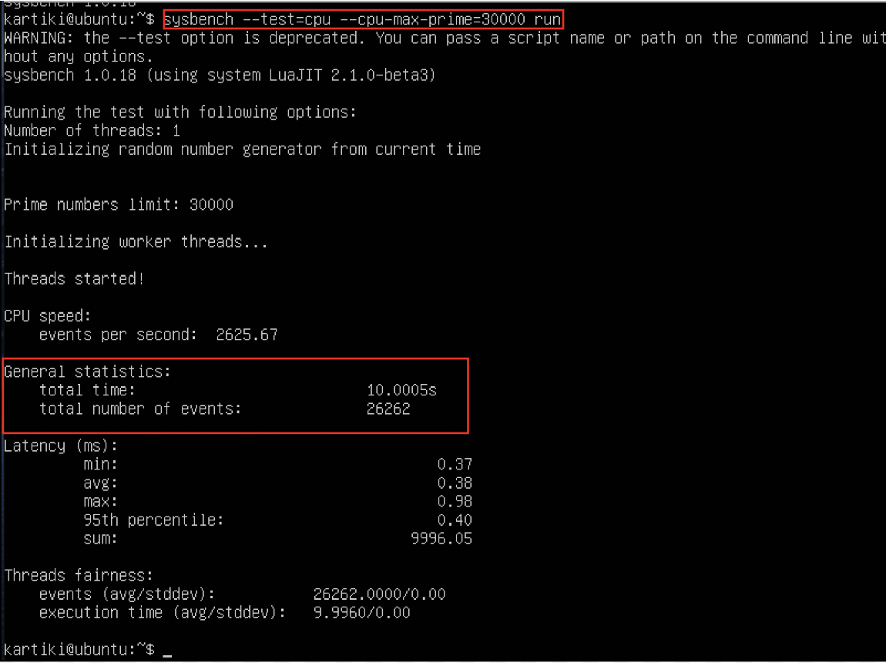

1. Running SysBench FileIo Testcase:

$ sysbench –test=fileio –file-total-size=2G –file-test-mode=seqwr \ prepare

$ sysbench –test=fileio –file-total-size=2G –file-test-mode=seqwr \ run

$ sysbench –test=fileio –file-total-size=2G –file-test-mode=seqwr \ cleanup

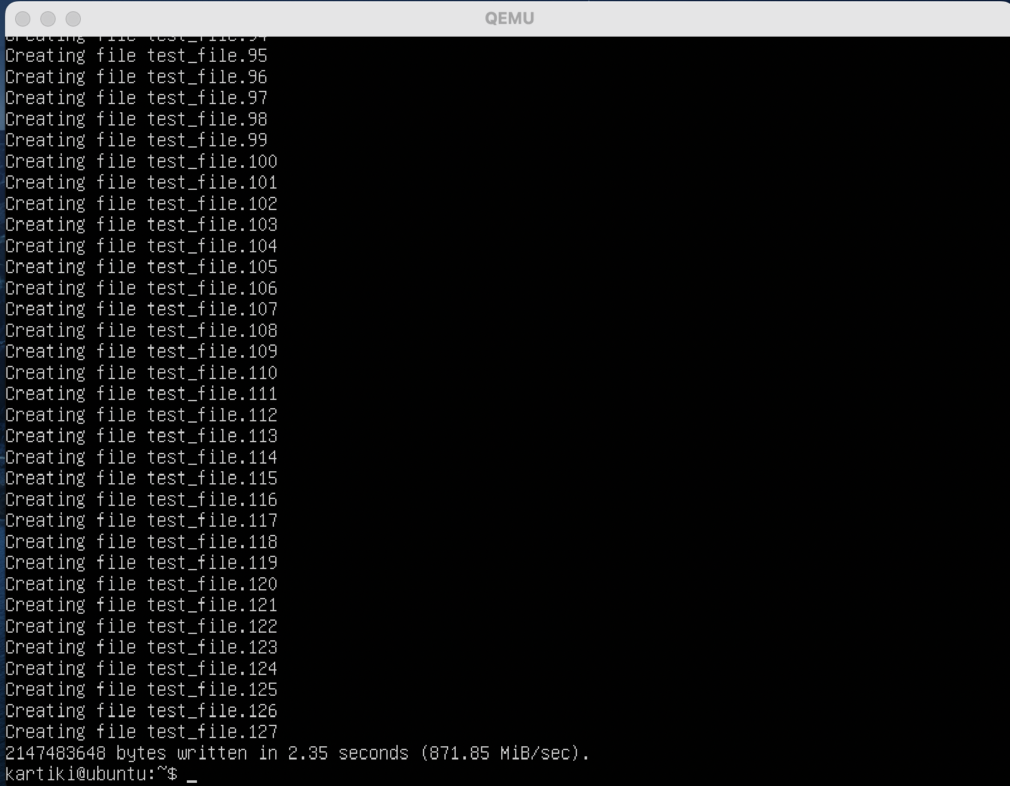

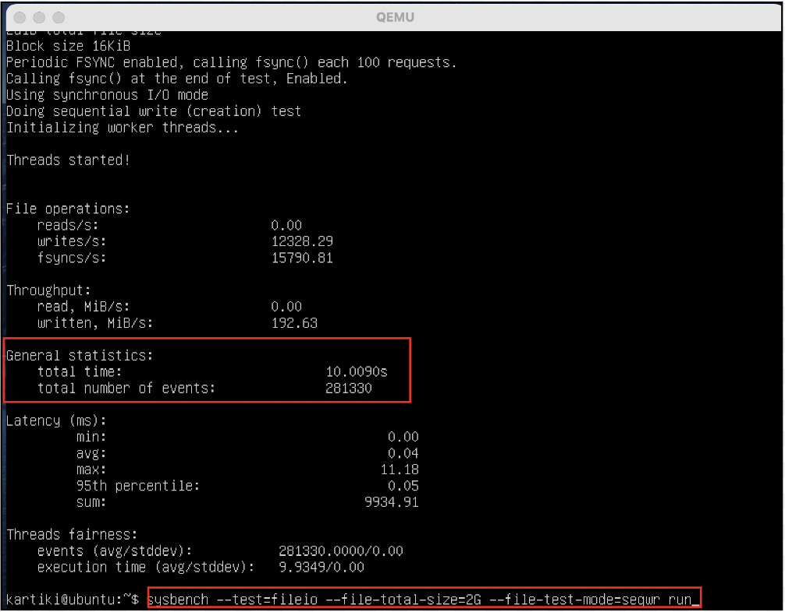

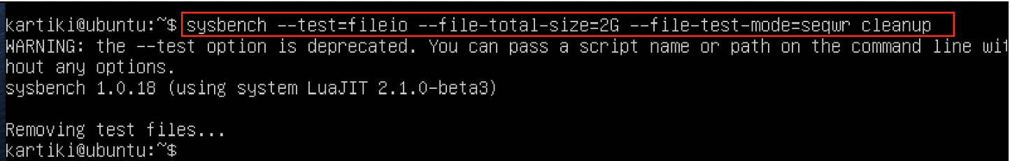

1. Running SysBench Memory Testcase:

$ sysbench –test=memory –file-block-size=2G run

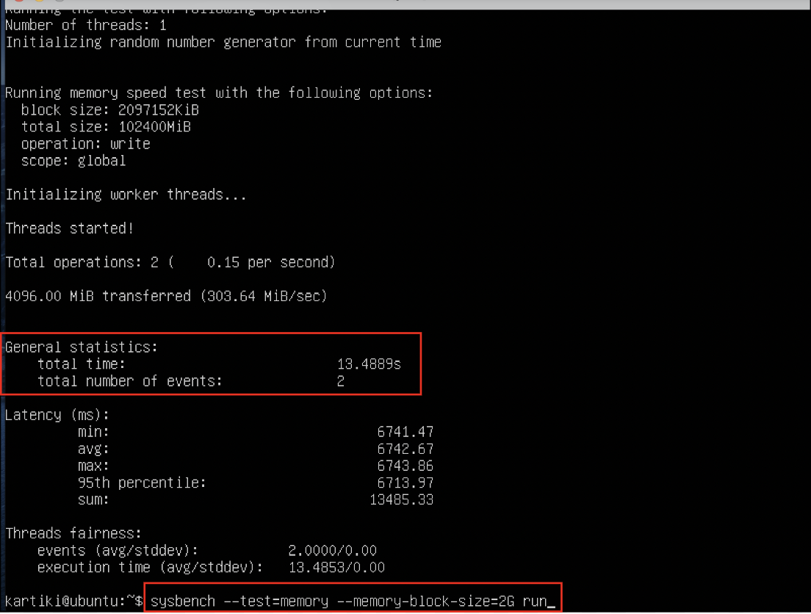

### Image Format: qcow2

1. Creating qcow2 image:

$ sudo qemu-img create ubuntu.img 15G –f qcow2



1. Booting Ubuntu:

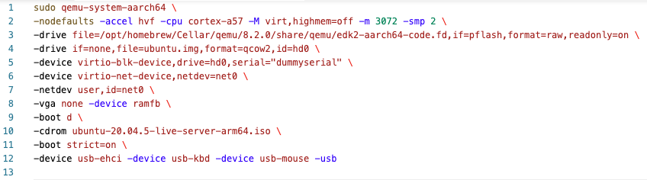

1. qcow2 Image Variation

Steps to run QEMU VM with different sets of CPU and Memory values:

1. CPU = 2, Memory = 2G

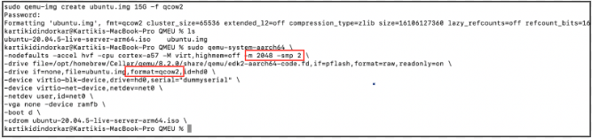

1. CPU = 4, Memory = 2G

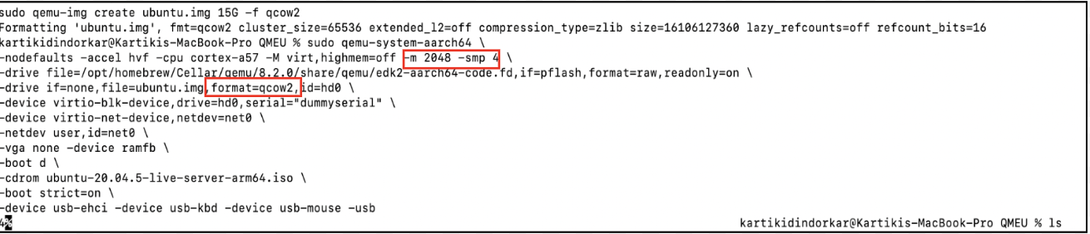

1. CPU = 4, Memory = 3G

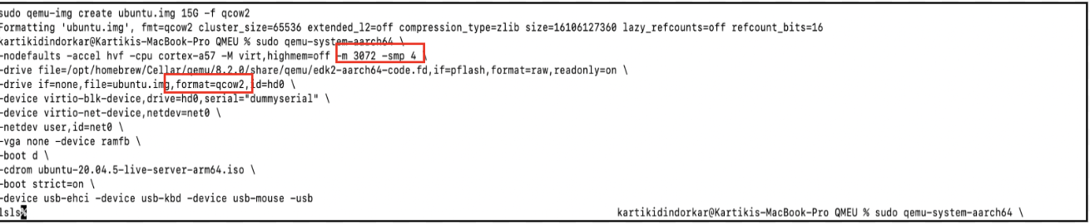

1. CPU = 2, Memory = 3G

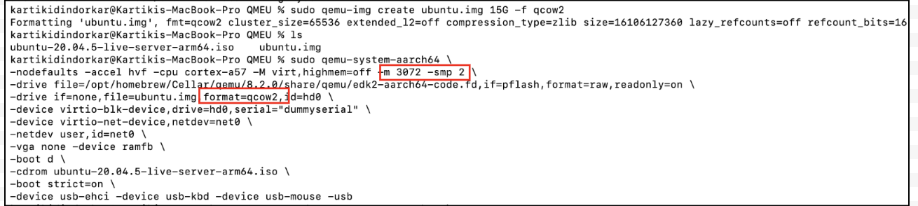

1. Running SysBench Testcases

I have used shell scripts to take sysbench readings for all the SysBench testcases. Refer section Automation and [HW1-SysBenchReadings.xlsx](https://github.com/Kartiki19/CloudComputing/blob/main/HW1/HW1-SysBenchReadings.xlsx) (attached in the HW1 folder as well) file for all the readings.

## B. Docker (OS Virtualization)

The experiment involves multiple test cases where there are variations in CPU and RAM allocated to the container. Also, 3 test modes of SysBench will involve 2 variations each. Thus, the variables and their variations are listed below:

|  |  |  |  |  |
| --- | --- | --- | --- | --- |
| **Sr No.** | **Variable Category** | **Variable Name** | **Parameter Name** | **Values** |
| 1 | Docker | Number of CPU | --cpus | 2, 4 |
| 2 | Docker | Memory Allocated | --memory | 2G, 3G |
| 3 | SysBench Test Mode | CPU | --cpu-max-prime | 30000, 60000 |
| Memory | --memory-block-size | 1G, 2G |
| FileIO | --file-test-mode | Sequential Write (seqwr), Random Write (rndwr), Random Read-Write (rndrw) |

1. $ docker run --cpus=2 --memory=2g ubuntu2004

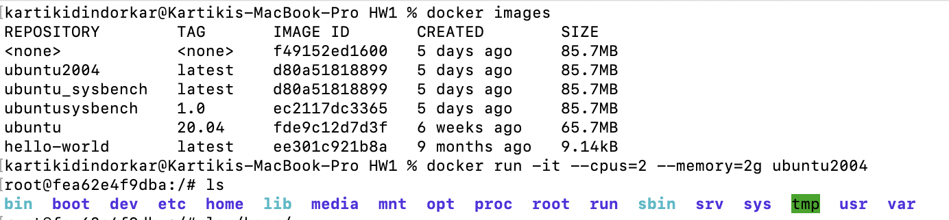

1. $ docker run --cpus=2 --memory=3g ubuntu2004

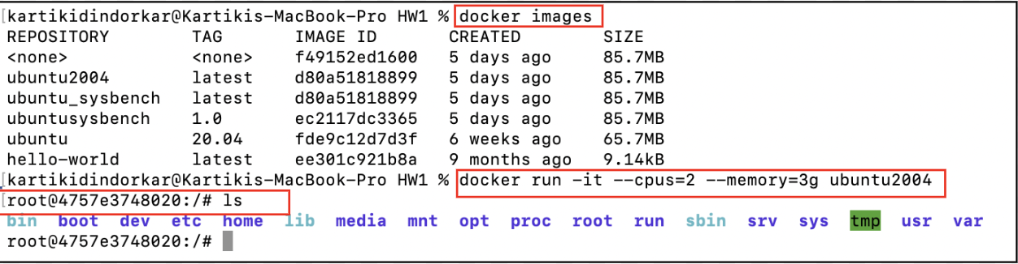

1. $ docker run --cpus=4 --memory=3g ubuntu2004

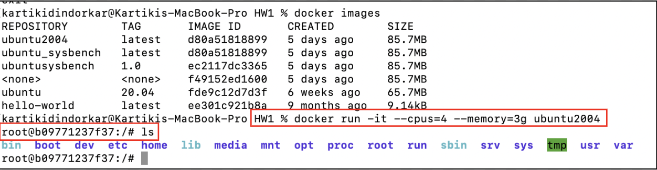

1. $ docker run --cpus=4 --memory=2g ubuntu2004

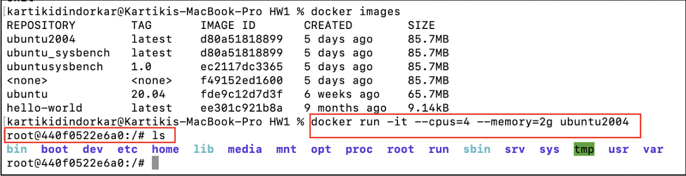

1. Running SysBench Testcases

I have used shell scripts to take sysbench readings for all the SysBench testcases. Refer section Automation and [HW1-SysBenchReadings.xlsx](https://github.com/Kartiki19/CloudComputing/blob/main/HW1/HW1-SysBenchReadings.xlsx) (attached in the HW1 folder as well) file for all the readings.

1. Docker Image history:

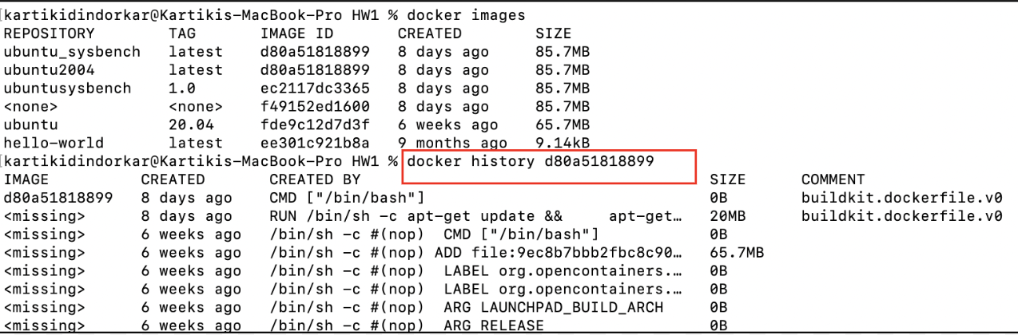

# Automation

I have created 2 shell scripts which:

* 1. Creates .csv file to store the results as:

“Test Mode | Parameter Value | Total Time (sec) | Number of Events | Events/Sec”

* 1. Once the testcase runs, it gives the output as:

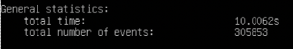

* 1. I used pattern matching to get the exact values of total time and total number of events:

|  |  |
| --- | --- |
| \s+ | Matches one or more white spaces to detect space between “total time” and its actual value |
| \K | Once the whitespaces have been detected, we should start reading the actual value, thus ‘\K’ is used to reset the start of the reported match |
| \d+ | Matched one or more digits |
| \. | Matches dot/decimal point |

* 1. For fileio test case, script will prepare the files, run the testcase and remove all the files after run.

## QEMU

1. Copy shell scripts from host OS to QEMU VM:

$ scp <host_username>@<ip_addr>:<path/of/files> <destination>

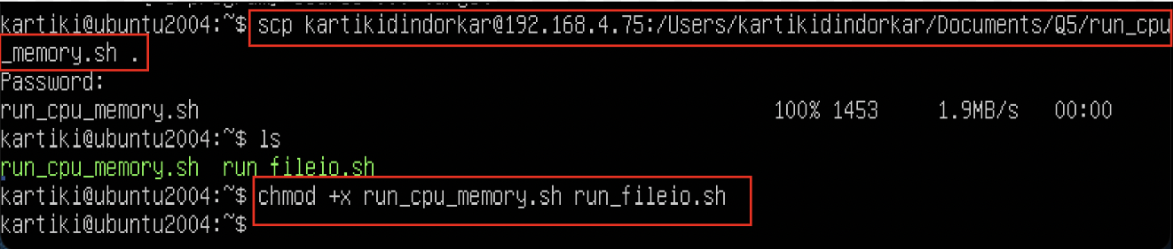

1. [run_cpu_memory.sh](https://github.com/Kartiki19/CloudComputing/blob/main/HW1/Shell%20Script/run_cpu_memory.sh)
2. Run the test mode as cpu with values –cpu-max-prime = 30000 and 60000
3. Run the test mode as memory with values –memory-block-size = 1G and 2G

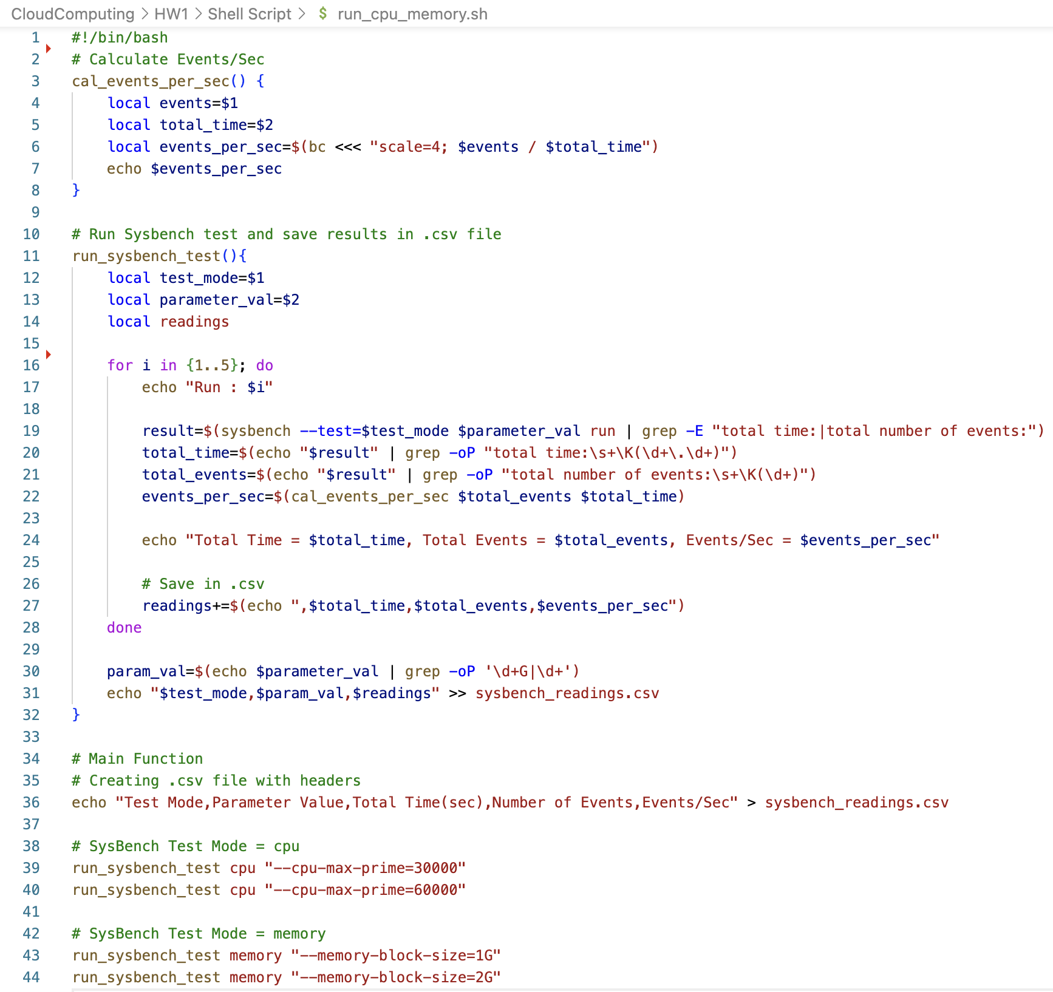

1. Gives Output as:

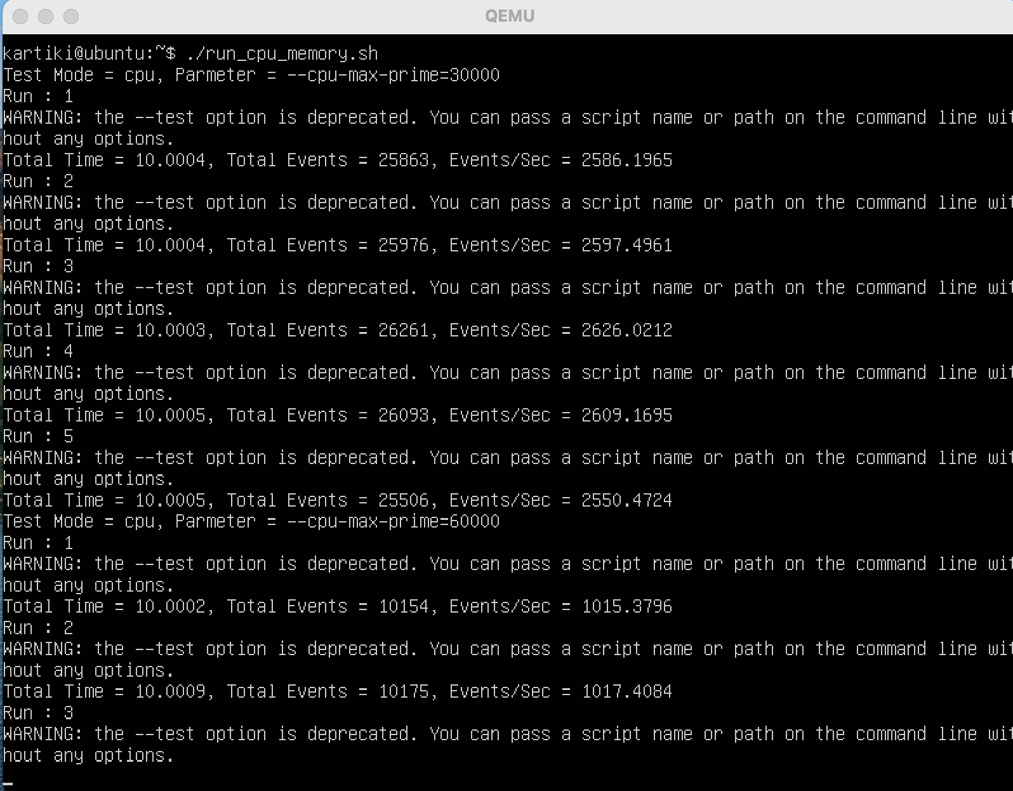

1. Another Output is sysbench_readings.csv file:

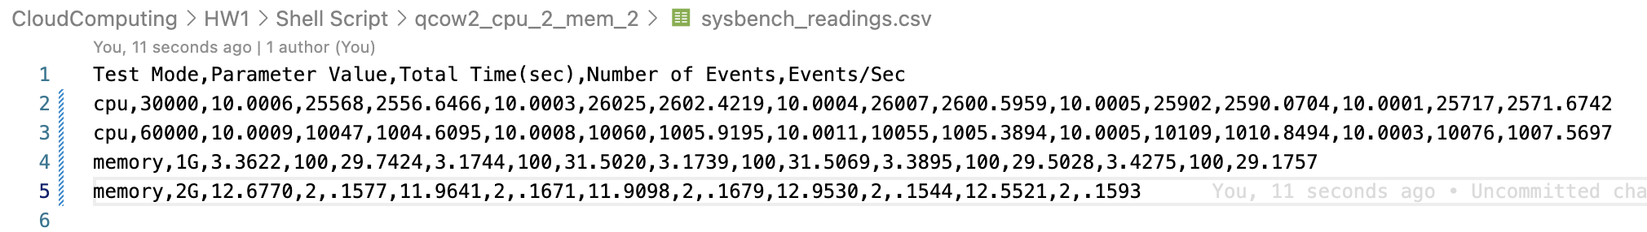

1. [run_fileio.sh](https://github.com/Kartiki19/CloudComputing/blob/main/HW1/Shell%20Script/run_fileio.sh)
   * 1. Run the test mode as fileio with values –file-test-mode:
     2. seqwr = Sequential Write
     3. rndwr = Random Write
     4. rndrw = Random Read and Write

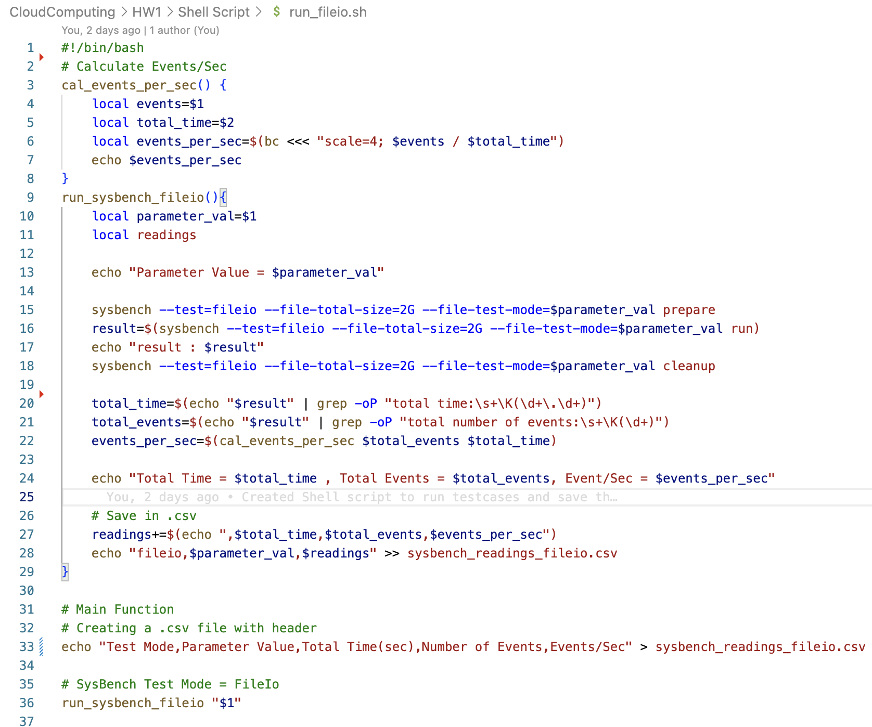

b. For fileio test mode, we need to drop the cache of host os after every testcase, thus there is no for loop used in this script, after every single run of this file, dropped the cache on host machine using:

$ sync && sudo purge

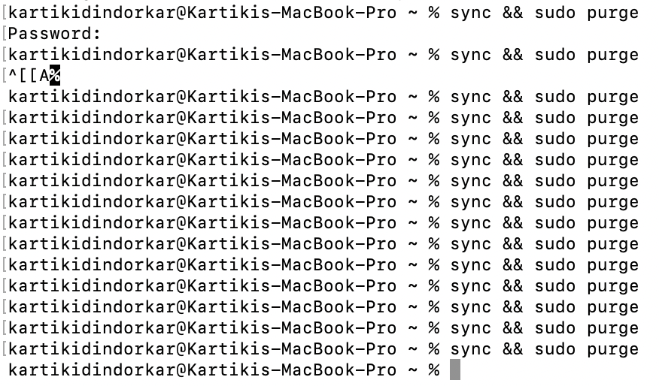

c. Gives Output as:

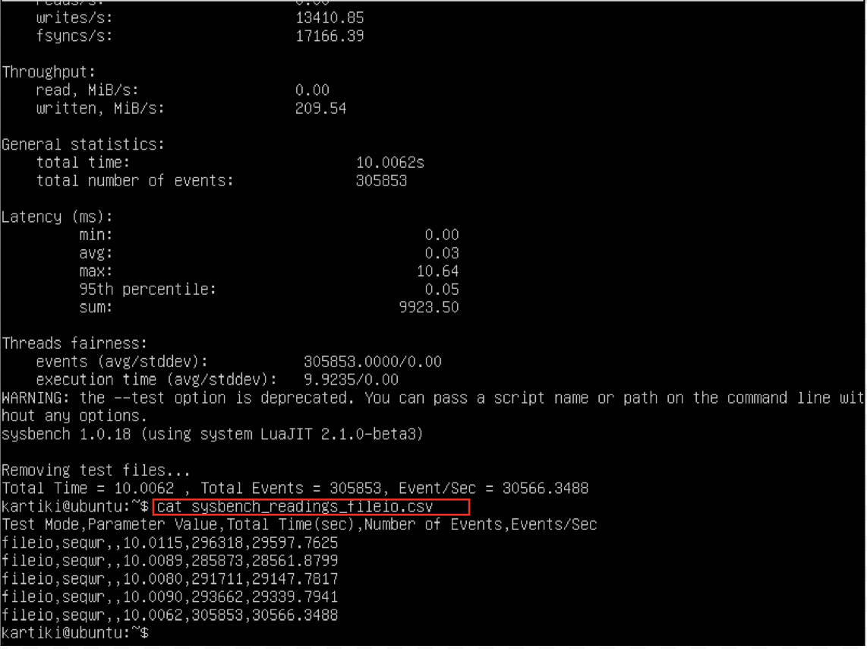

* + 1. Another output is sysbench_readings_fileio.csv file:

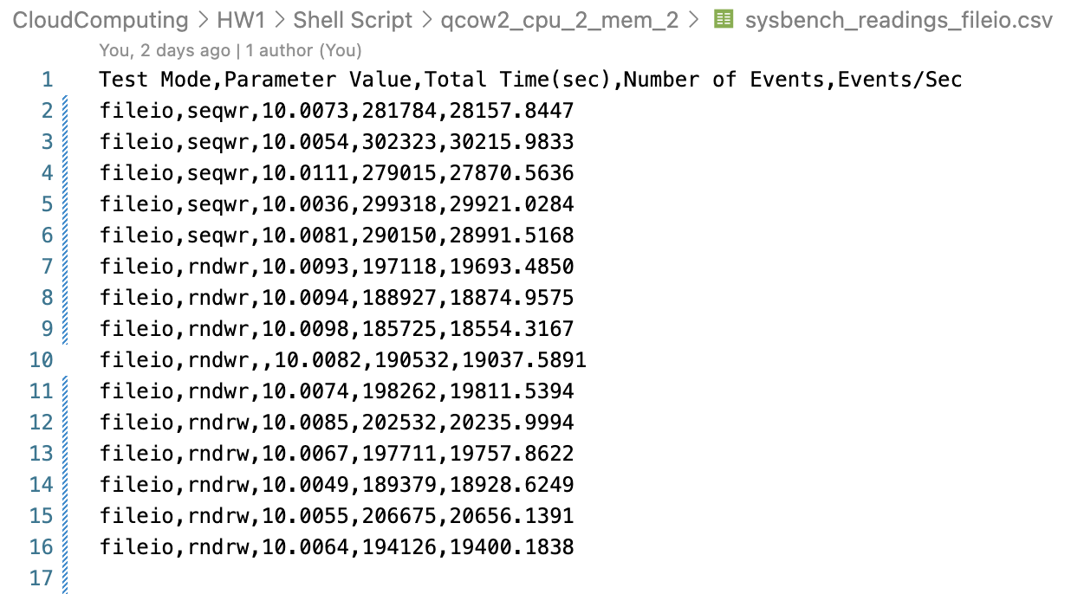

1. Copy Output files (SysBench Readings Output .csv) to host machine:

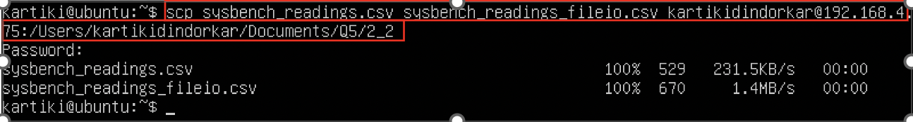

## Docker

1. Copy shell script to running container:

$ docker cp <file_path_host_mch> <image_id>:<path/docker>

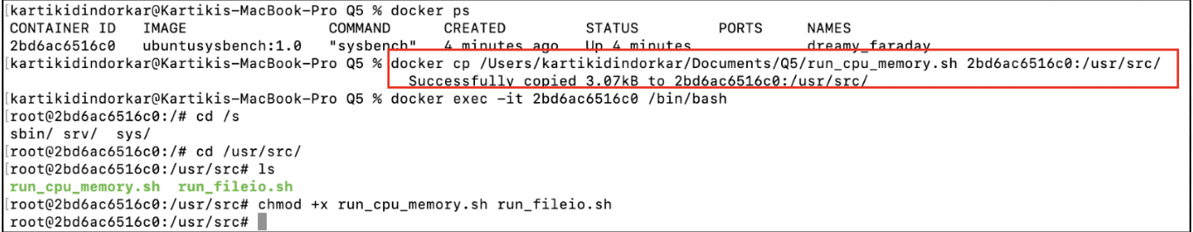

1. Running cpu and memory SysBench testcase same as VM:

$ ./run_cpu_memory.sh

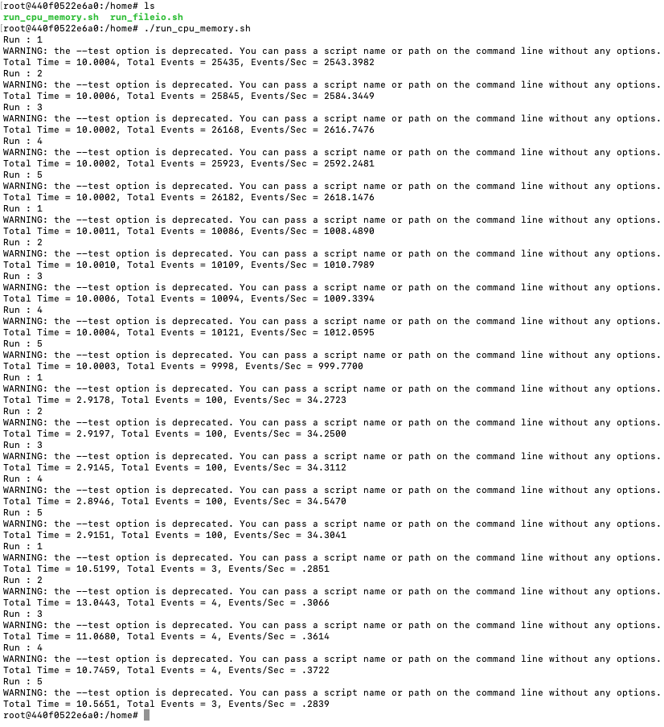

1. Running fileio test case of SysBench same as VM:

$ ./run_fileio.sh seqwr

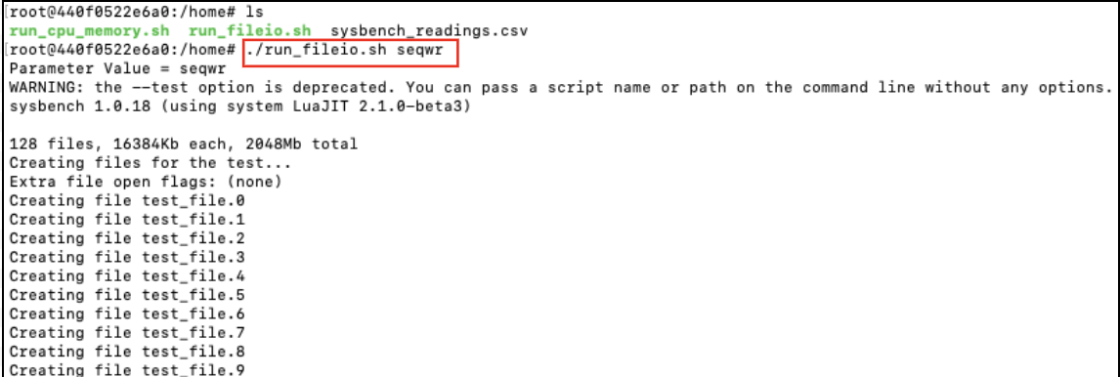

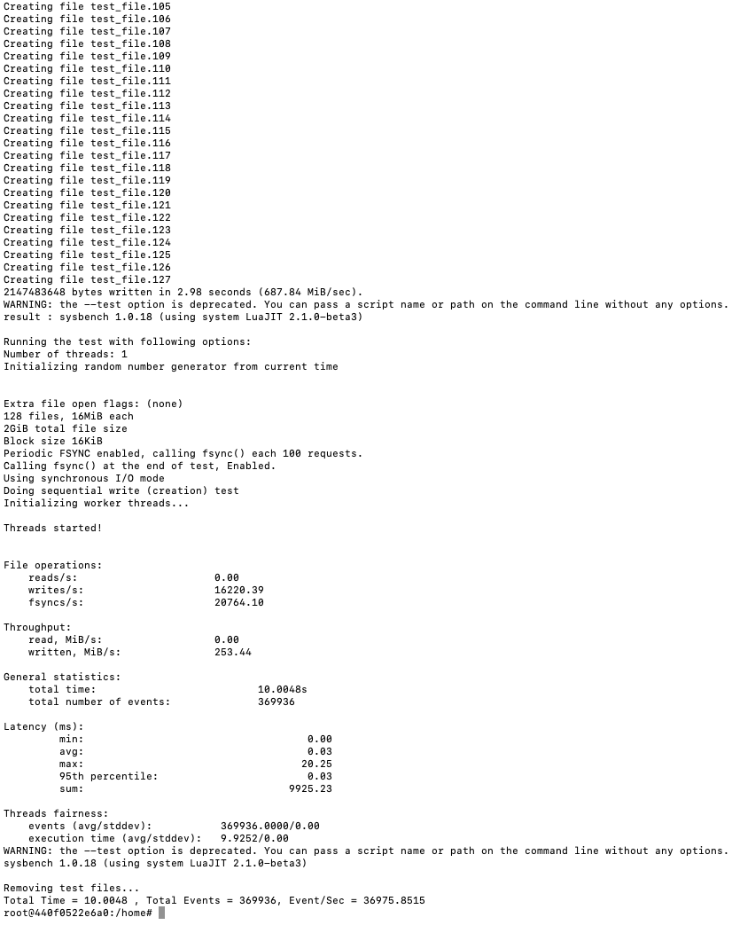

1. For fileio testcase, after running each testcase we need to drop cache from host VM, using:

$ sync && sudo purge

1. Run for each test case 5 times and for every test mode (seqwr, rndwr, rndrw)

$ ./run_fileio.sh rndwr

$ ./run_fileio.sh rndrw

1. For Docker, output files, i.e., all the .csv files are stored in “HW1/Shell Script/Docker_<testcase_mode>/” folder
2. For VM, output files, i.e., all the .csv files are stored in “HW1/Shell Script/<image_format>_<testcase_mode>/” folder

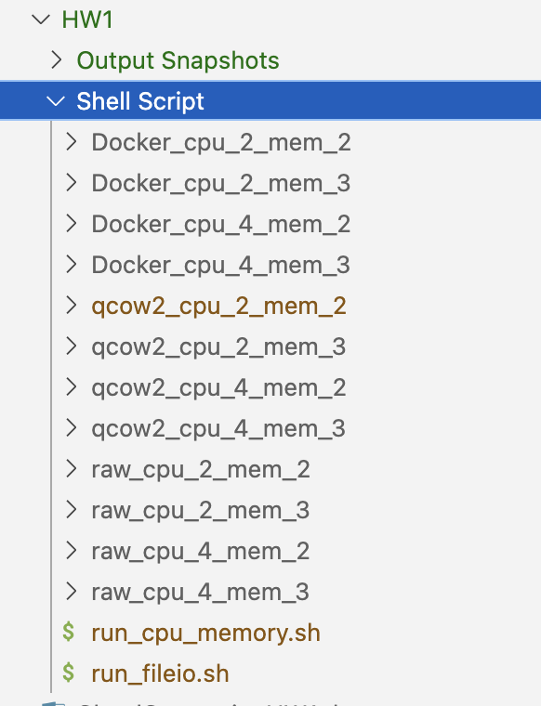

1. All the readings are accumulated and stored in “[HW1-SysBenchReadings.xlsx](https://github.com/Kartiki19/CloudComputing/blob/main/HW1/HW1-SysBenchReadings.xlsx)” (attached in HW1 folder) file to perform further calculations:
   1. Docker readings:

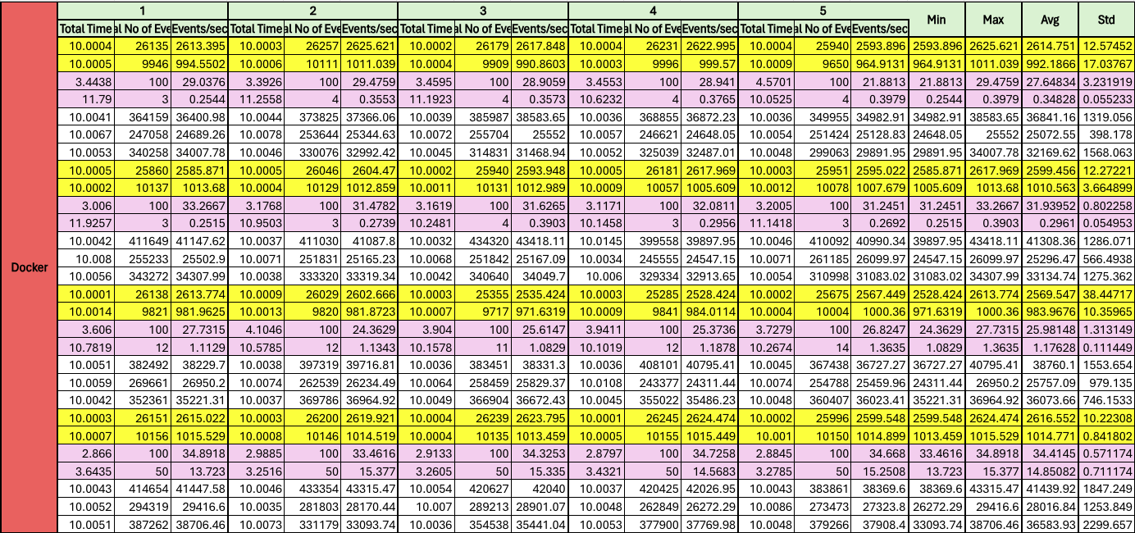

* 1. QEMU VM Readings:

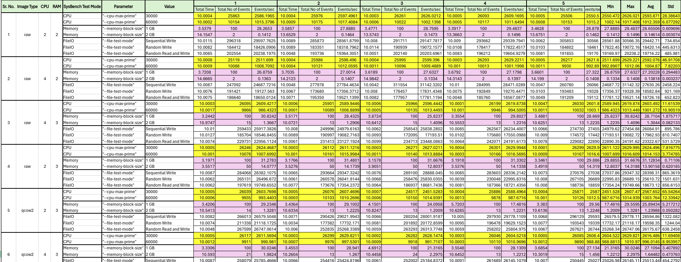

# Analysis

Following is the result of our experiments:

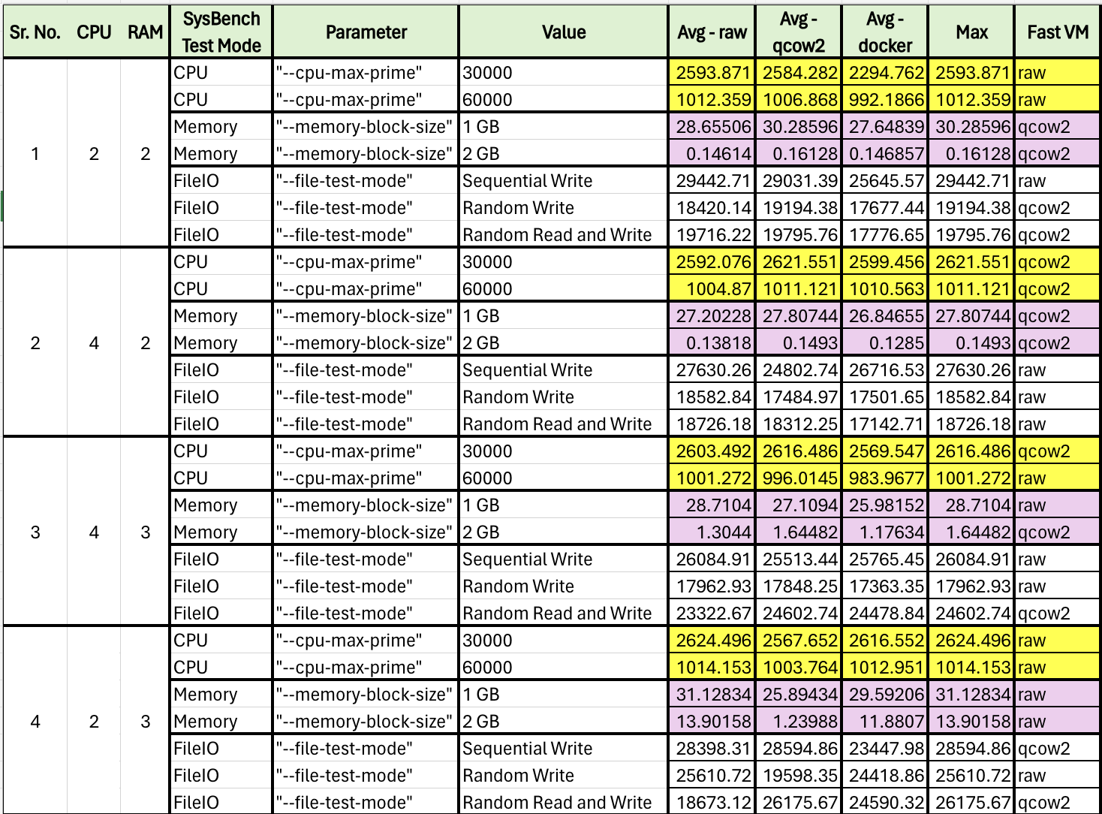

1. Based on our experiment results, we can conclude that the System Virtualization gives better performance i.e., a greater number of events per sec than OS virtualization.
2. In the case of CPU test cases, as we increase our parameter’s value, the events/seconds reduced.
3. We have seen similar results in the case of memory test cases, where increasing memory block size gives reduced events/sec.
   1. Also, when the memory allocated to the VM is increased, the events/sec has increased.
4. For FileIO testcases, the sequential mode has performed well and given the maximum events/sec.

# Vagrant

1. Download Vagrant: <https://developer.hashicorp.com/vagrant/install> OR
2. Install Vagrant using brew:

$ brew install vagrant

1. Download and Install VirtualBox: <https://www.virtualbox.org/wiki/Downloads>
2. Search for the ubuntu box from: <https://app.vagrantup.com/boxes/search>
3. Create [Vagrantfile](https://github.com/Kartiki19/CloudComputing/blob/main/HW1/Vagrantfile):

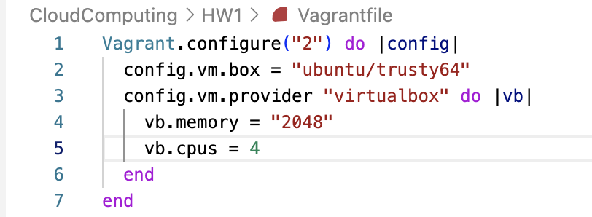

1. Run the Vagrant:

$ vagrant up

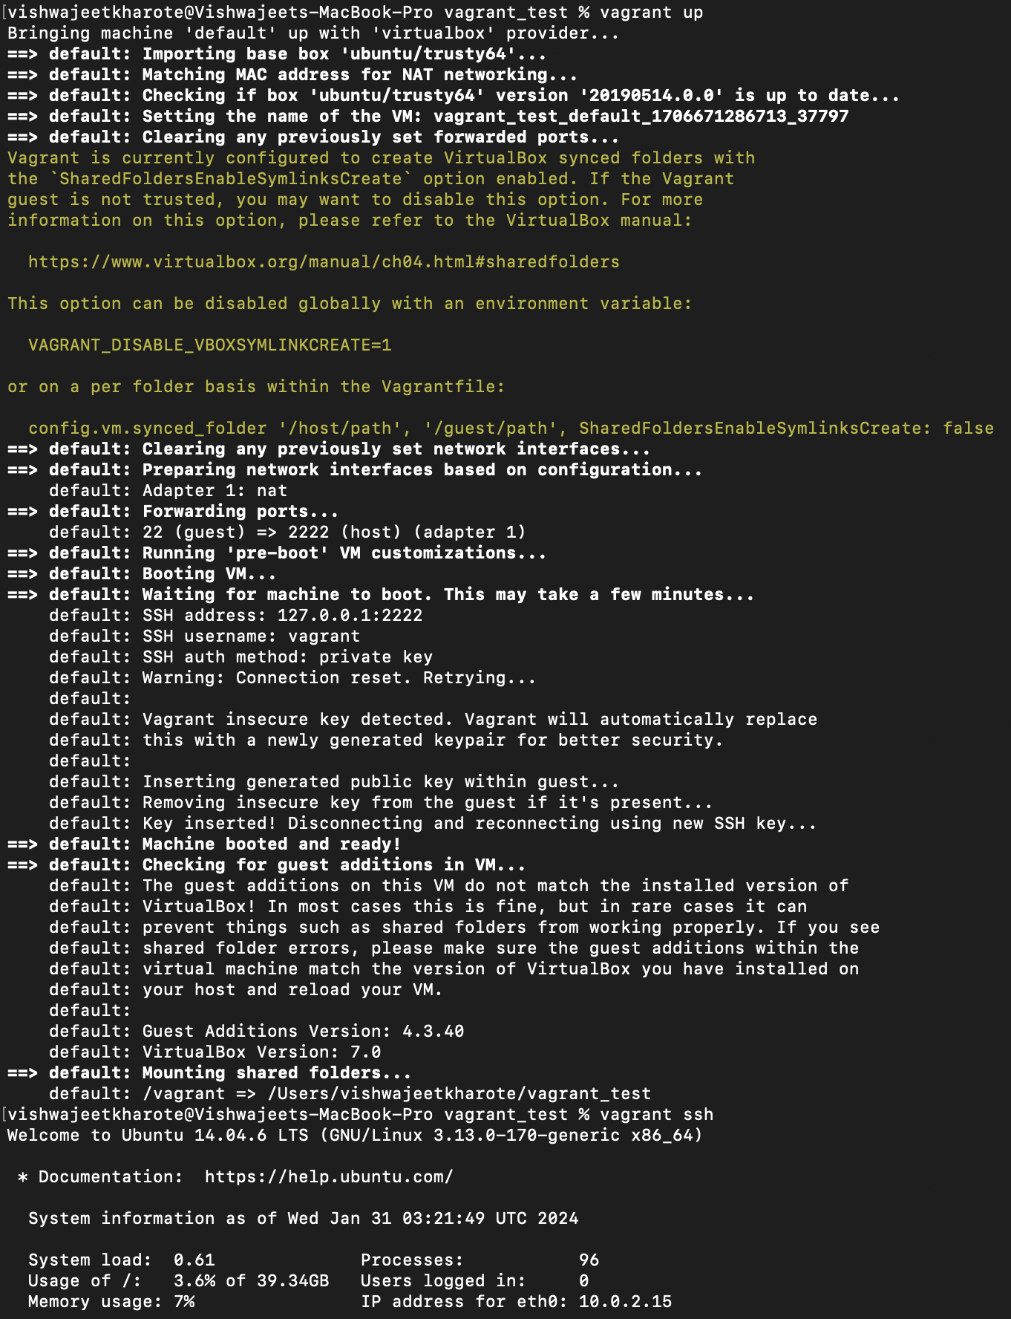

1. Once it is done, ssh into the VM:

$ vagrant ssh

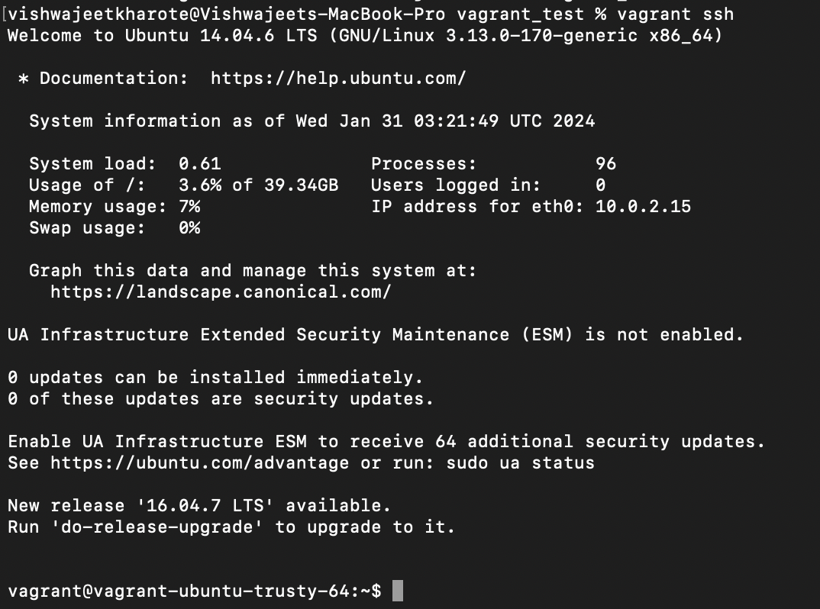

1. You can install SysBench in the virtual box and run the testcases:

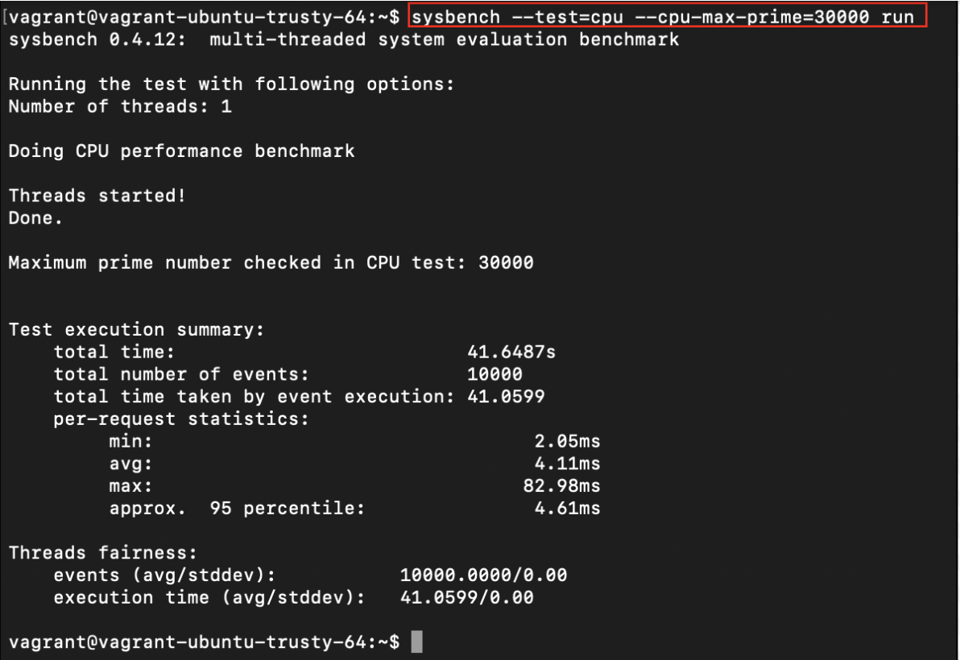

1. When you start the VM from terminal, you can see it is running in the virtual box application:

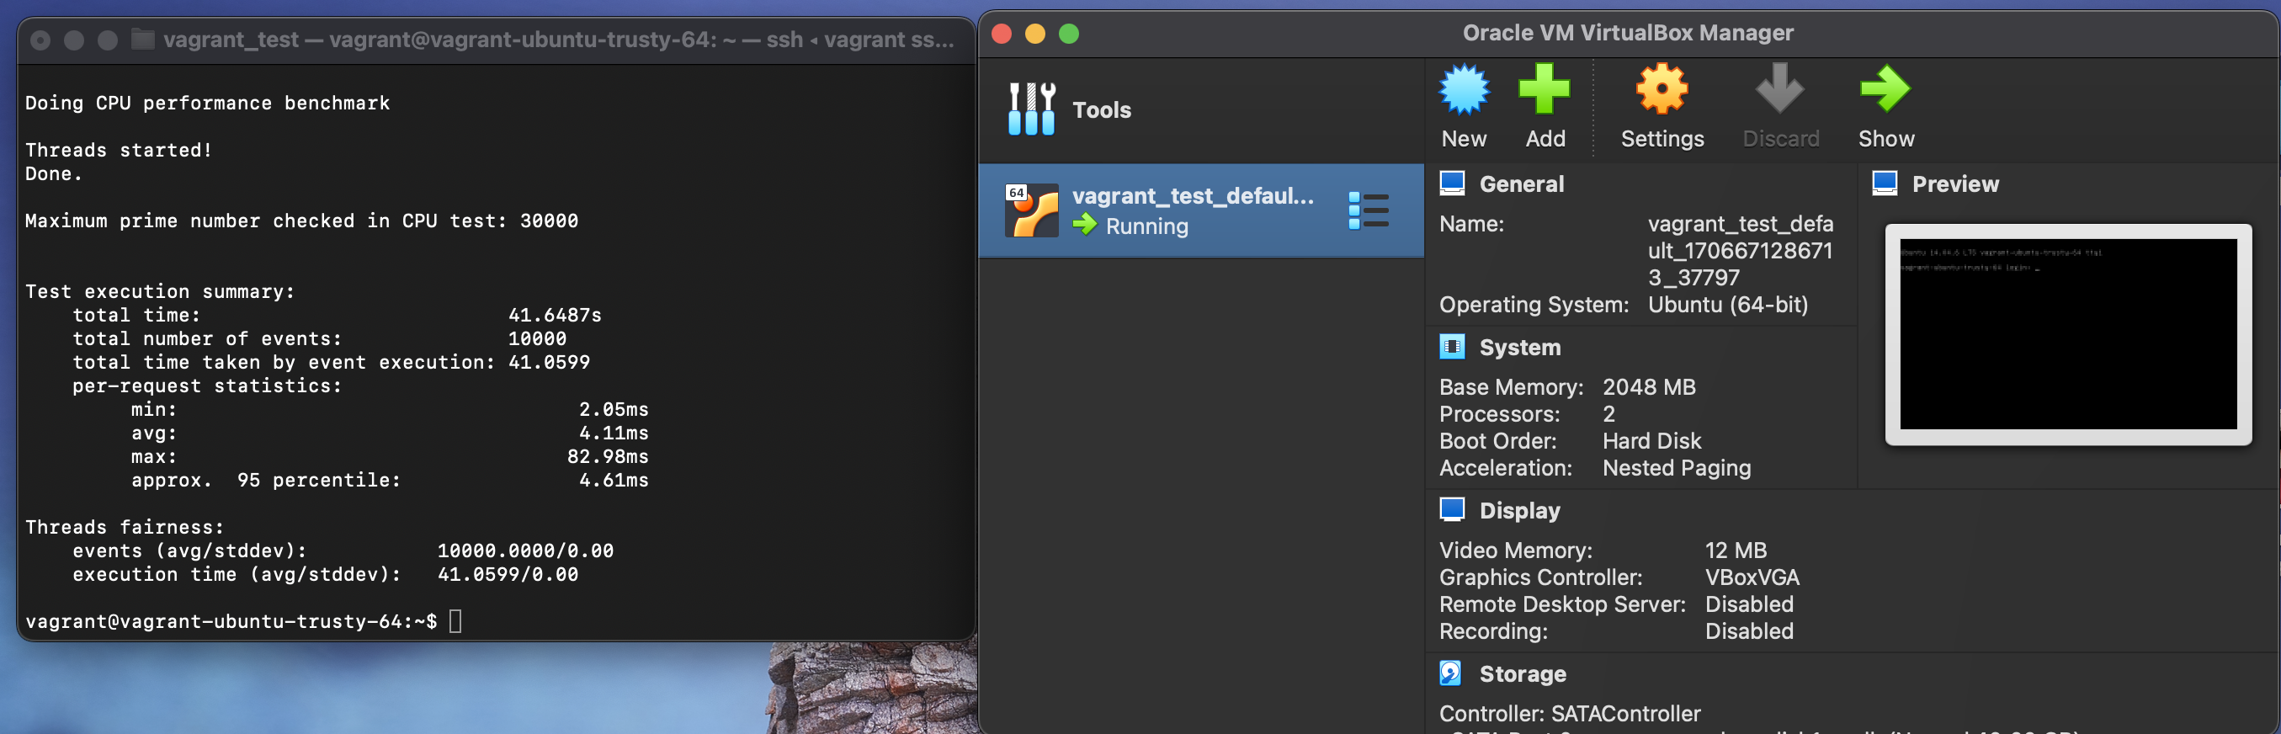

# Encrypted Image

1. Create a qcow2 encrypted image using:

$ qemu-img create --object secret,id=sec0,data=abc123 -f qcow2 –o \

encrypt.format=luks,encrypt.key-secret=sec0 \

ubuntu_encrypted.qcow2 15



1. Install the VM using following command, where pass the secret-key to “encrypt.key-secret”

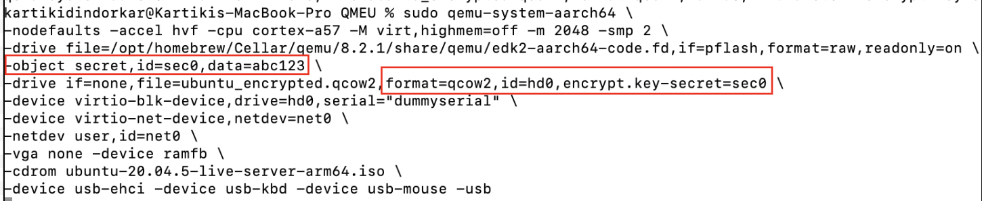

1. Run CPU SysBench test case:

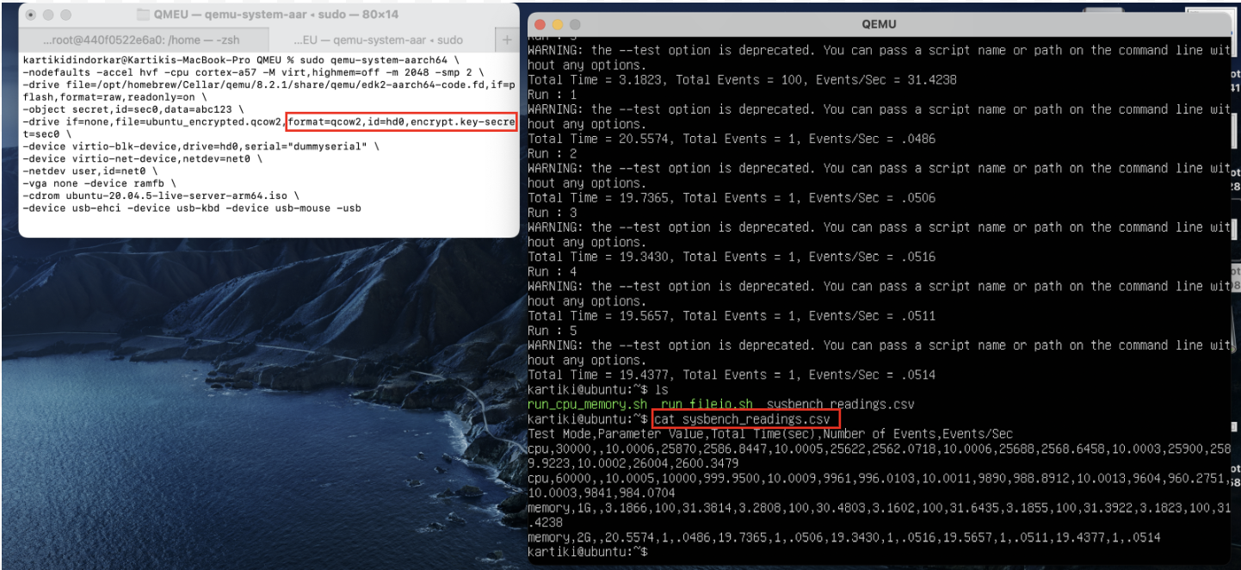

1. Run FileIo SysBench Testcases

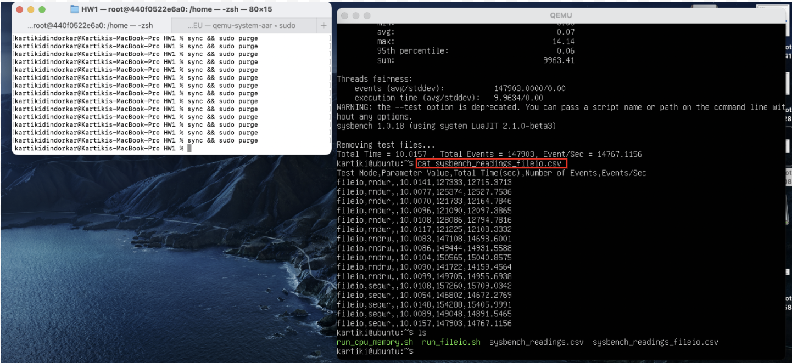

1. Results for encrypted image

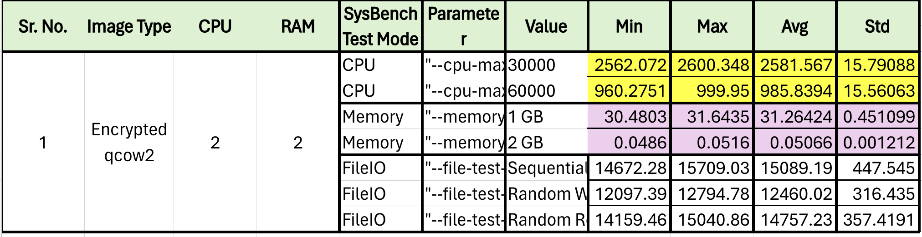

1. Rebooting VM without “-cdrom” option

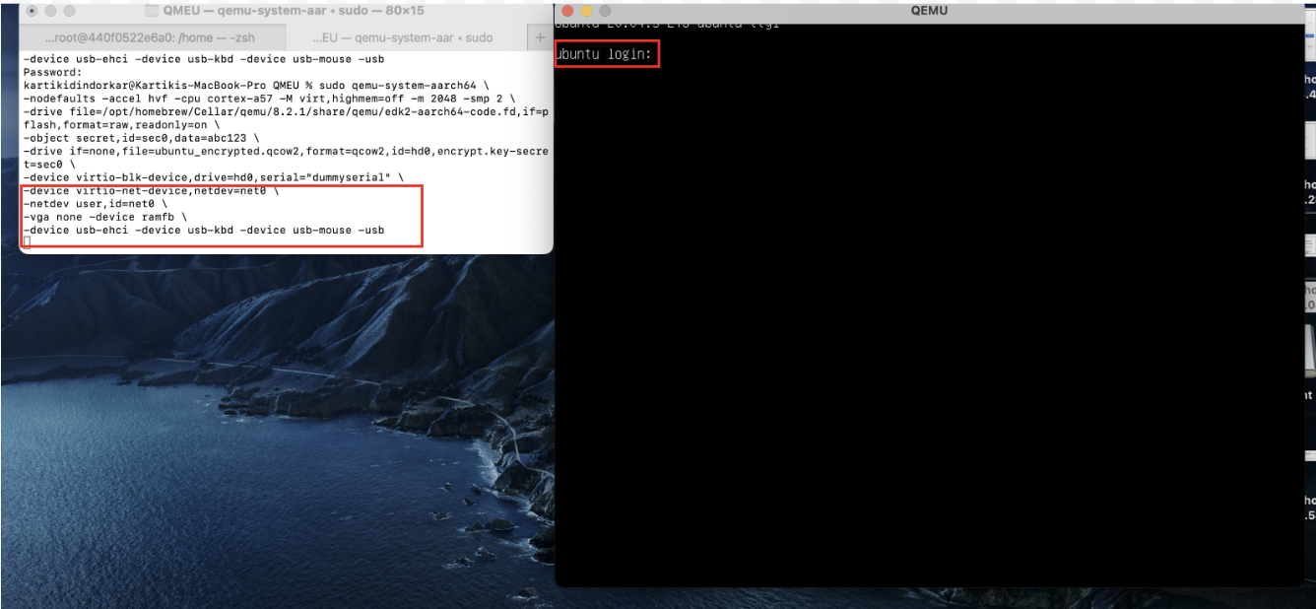

# References

[1] QEMU Manual: <https://www.qemu.org/docs/master/system/qemu-manpage.html>

[2] SysBench Manual: <https://imysql.com/wp-content/uploads/2014/10/sysbench-manual.pdf>

[3] Vagrant in MAC OS: <https://github.com/ppggff/vagrant-qemu?tab=readme-ov-file>